**SHRI SHAMBHUBHAI V. PATEL COLLEGE OF**

**COMPUTER SCIENCE & BUSINESS MANAGEMENT**

Affiliated to

VEER NARMAD SOUTH GUJARAT UNIVERSITY,

SURAT

A PROJECT REPORT ON

**EDUCARE**

As a partial fulfilment for the degree of

Bachelor of Computer Application (B.C.A.)

Academic Year: 2019-2020

**Submitted By:** **Guided By:**

Sutariya Jil V. (1865) Prof. Binal Naik

Talaviya Jay B. (1867)

Talaviya Vaibhav J. (1868)



**Shri Shambhubhai V. Patel College of Computer Science & Business Management**

Near I.C.Gandhi School, Sumul Dairy Road, Surat. (Gujarat) India.

**C E R T I F I C A T E**

*This is to certify that the project entitled* **EDUCARE** *has been carried out by Mr./Ms****.* Sutariya Jil V. Talaviya Jay B.**

**Talaviya Vaibhav J.**

*of Bachelor of Computer Application, Semester VI Exam No.* **1865 &**

**1867 & 1868.** *towards fulfillment of the course, for the Academic Year 2019-20.*

Mentor/Guide I/C. Principal

Date: Date:

|  |  |
| --- | --- |
| PROJECT OF B.C.A. | |
| Academic Year: Approved by: | **2019-20** |
|  |
|  |
| Examiners | |

|  |  |
| --- | --- |
|  | |
|  |  |
|  |
|  |
|  | |
|  | |

**INDEX**

|  |  |  |
| --- | --- | --- |
| SR.NO | PARTICULAR | PAGE.NO |
| 1 | **Introduction** | 1 |
|  | 1.1 Project Profile | 1 |
|  | 1.2 Features | 2 |
|  | 1.3 Benefits | 2 |
|  | 1.4 Modules | 2 |
|  | 1.5 Scope of system | 3 |
| 2 | **System Environment** | 4 |
|  | 2.1 Hardware Used | 4 |
|  | 2.2 Software Used | 5 |
| 3 | **Problem Specification** | 6 |
|  | 3.1 Introduction, Objective and Purpose | 6 |
|  | 3.2 System Model | 7 |
|  | 3.3 Feasibility Study | 10 |
| 4 | **Risk Identification and Management** | 12 |
|  | 4.1 Risk Monitoring | 12 |
| 5 | **Technology Used for Development** | 14 |
| 6 | **Planning** | 21 |
|  | 6.1 System Planning | 22 |
|  | 6.2 Time Line Chart | 23 |
| 7 | **System Analysis** | 24 |
|  | 7.1 Database Design | 24 |
|  | 7.2 ER Diagram | 25 |
|  | 7.3 Data Flow Diagram | 26 |
|  | 7.4 Process Specification | 35 |
|  | 7.4 Data Dictionary | 42 |
| 8 | **Designing** | 55 |
|  | 8.1 User Interface | 55 |
| 9 | **Testing** | 67 |
|  | 9.1 Software Testing | 67 |
|  | 9.2 Unit Testing | 68 |
|  | 9.3 System Testing | 69 |
| 10 | **Reference** | 75 |

# Introduction

* **Project Profile**
* **Features**
* **Benefits and Modules**
* **Scope of System**

## Project Profile

|  |  |
| --- | --- |
| Project Title | EDUCARE Education System |
| Project Category | Online Learning Site |
| Project Duration | 4 Months |
| Front End | PHP  HTML  CSS, Bootstrap, Ajax, JavaScript |
| Back End | MySQL |
| Development Tools | Adobe Dreamweaver CC 2019  PhpMyAdmin  Sublime text 3 |
| Internal Guide | Prof. Binal naik |
| Developed By | Sutariya Jil V  Talaviya Jay B.  Talaviya Vaibhav J. |

## Features

* Online Course marketing tools
* Online User and Tutor registration
* Tutor can add course
* User can Chat with Tutor
* Course management on-site tools
* Online Learning Platform
* Survey for feedback

## Benefits

* Provides Backup
* Provides Security
* Consolidate different teams
* Lower overheads
* Smooth workflows in the entire event lifecycle
* More focused on learning in easy way
* Efficient data management

## Modules

1. Admin Modules.

2. User Modules.

3. Course Modules

4. Package Modules

5. Order Modules.

6. Payment Modules.

## Scope of system

* Online Learning or Tutorial is a 21st century newer way of learning in a very easiest way possible. In this learning are made possible in a very engaging manner and you can learn where ever you want and whenever you want. This makes learning possible in every way possible.
* Online learning is distance education that is made available through an internet connection. Due to this mode of delivery, online learning can be made accessible worldwide.
* Students who have access to a PC and internet connection can pursue an online degree, choosing from a range of learning models and programmed to suit their lifestyle and working schedule.
* Online learning can be synchronous and/or asynchronous. In many cases, asynchronous online learning with its greater flexibility provides the perfect alternative to campus-based study for busy working professionals.
* Distance education has come a long way since its inception, giving rise to modern online education that opens up new possibilities for learning that fits the 21st century. With the aid of online educational technology, working professionals around the world can now earn an advanced university degree without interrupting their career.
* It’s a highly interactive approach to online learning, designed to help working professionals move ahead of both personally and professionally in an interconnected world

# System environment

* **Hardware configuration**
* **Software configuration**

## Hardware configuration

* **Client-Side Configuration**

|  |  |
| --- | --- |
| Processor | Intel Core i3 processor |
| Hard Disk | 15 GB |
| RAM | 1 GB |

* **Server-Side Configuration**

|  |  |
| --- | --- |
| Processor | Intel Core i5 processor |
| Hard Disk | 15 GB |
| RAM | 8 GB |

## Software configuration

* **Client-Side Configuration**

|  |  |
| --- | --- |
| Operating System | Windows 10 |
| Internet | Required |
| Browser | Chrome (Recommended) you can use any latest browser |

* **Server-Side Configuration**

|  |  |
| --- | --- |
| Operating System | Windows 10 |
| Front End | HTML |
| Back End | PHP, MYSQL |
| Framework | CodeIgniter |

# Problem Specification

## Introduction, Objective and Purpose

* **Introduction**
* Personality assessment with explore online talent is an Online Website that the aim of this is to people can spread their talent to others. Anybody can display his ability of multi talent to others. Person can display his talent on these sites.
* Educare is platform which gives facilities of various services provided by service provider.
* This is one type of stage to display all type of talent of any people dancing, singing, painting, music, cooking, extra talent any type of talent. In sometime people have a new talent but he/she can’t get any stage to display her talent.
* His is one type opportunity in this people can get stage to display her/his talent and new creativity to world. People can do business of their talents with others people.
* **Objective**
* The administrator easy interface for different task such as manages the talent user, manage the course and manage the category.
* User gets easily information about various course & category.
* User will show course date-time for particular Tutor.
* **Purpose**
* Explore talent website is developing with the purpose of providing course.
* Get various course information.
* Get various category information.
* View upcoming lecture.
* Show running lecture and it’s time on particular places.
* Show the review of lecture.
* User can chat with the tutor.

## System Model

* **Prototype model**

**Why we use prototype model?**

* Our aim is developing a site which is much Friendly for users, so we Follow Prototype Model. First we gather requirement which users rarely want. Then we develop a working model related to the Customer requirement & try to implement all the things.
* Then we move to Customer evaluation & get the review from Customer, if Customer is Satisfied then it is implemented Otherwise We follow prototype model steps again until user is satisfied.

**How to work prototype model?**

* Prototyping is defined as the process of developing a working replication of a product or system that has to be engineered. It offers a small scale facsimile of the end product and is used for obtaining customer feedback as described below:

Is used to

Built / Revise

Model

Listen To The Customer

Used for

Result into

Customer Test/Drives

Mock-Up

**Figure 1 Prototype Model**

Prototype is a process which is basically developed where,

1) User is not sure of the requirement.

2) Develop make in unsure of the efficiency of a particular algorithm.

Proto type model gives just outline or idea about the system.it does not contain all the document.

Prototype model gives a quick design which focus on the aspect that should be receble the customer so, that is changes are required it can be done in initial status prototype is a recursive model because the working model is change repeated when the customer need changes.

**Steps in Prototype Model**

YES

NO

Is It Satisfactory

Review Prototype

Customer Evaluation

Develop a Working Model

Requirement Gathering/Refinement

**1.** **Requirement gathering & Refinement**

Both developer & customer work together and define overall Object of the software and identify the requirements which are to be fulfilled.

**2. Develop a Working Model**

A working model which has important feature is develop so that customer in identify any extra feature is develop so that customer in identify any extra feature acquired or error in application.

**3. Customer Evaluation**

User is give chance to work on the prototype model and evaluated. This can help in finding the changes to be alone.

**4. Review Prototype**

The prototype is review for is efficiency and it is determined it changes is required if the user requires a changes refinement in requirement is done of is prototype model is implemented.

The process of prototyping repeated till both the user & developer find all the necessary feature that are required for the problem solved.

* **Advantage of Prototype**

1. Misunderstanding between develop team & user can be identify as customer uses the prototype version of s/w.

2. If the software is not user friendly it can be identify in the early stages.

3. The cost of software is very less.

4. System can be delivered within proper time and delay are minimize.

* **Disadvantage of prototype**

1. There may be too much variation in requirements each time the prototype is evaluated by the customer.

2. Poor Documentation due to continuously changing customer requirements**.**

3. It is very difficult for the developers to accommodate all the changes demanded by the customer

## Feasibility Study

* A Feasibility Study is very important role in the development of the system. But when it is the case of development of any software it is important to increase much more because in this case one should be clear about the availability of the time and resources.
* Before starting the development of the study because the successful completion of the project depends upon its feasibility.
* **Economic feasibility**
* Economic analysis is the most usually used method for estimating the effectiveness of a client system. In this feasibility study below points were discussed.
* How to provide good quality of Service in less cost?
* How to gain more income by keeping reasonable fees from member?
* How can build proposed system in less cost with effective GUI?
* How to separate the business logic from the interface?
* **Technical Feasibility**
* In Technical and system feasibility study we discussed on below points.
* Analysing about performance of server compare to proposed system.
* Which technology to use, as a Font-End & Back-End, for proposed system?
* Which operating system if more efficient? Or Generalize OS for Portability.
* Security of data in server.
* **Operational feasibility**
* Operational feasibility is a measure of how well a proposed system solves the problems, and takes advantage of the opportunities identified during scope definition and how it satisfies the requirements identified in the requirements analysis phase of system development. Hence forth, the system developed was also operationally feasible

# Risk Identification and Management

* **Equipment risk management:**
* Equipment breakdown insurance covers the cost of mechanical breakdowns, Damage caused by power surges, operator error and more.
* Business interruption insurance cover any income lost because of equipment failure. Some carries will help prevent breakdowns by offering infrared testing, inspections and assistance in sourcing replacement for damaged equipment.

## Risk monitoring

* [Risk](https://www.sciencedirect.com/topics/computer-science/risk) monitoring activities implement the [risk](https://www.sciencedirect.com/topics/computer-science/risk) monitoring strategy by gathering information through automated or manual means, alerting or reporting on information relevant to intended purposes for risk monitoring, and providing inputs to ongoing risk assessment and response processes.
* Depending on risk assumptions, constraints, priorities, and tolerance levels, the set of risk monitoring practices actually implemented at any one time may differ from what is documented in the risk monitoring strategy.
* **Superior Risk Assessment Capabilities:**
* Proper assessment of risk helps to drive decision making in a quality management system. Master control’s online risk management solution allow user to configure multiple risk type for evaluating different categories of operational risk.
* From anywhere within the master control system. User can launch sophisticated risk assessment tools, which will enable them to analyse the hazards associated with any process or activity. Once defined, user can prioritize adverse events and define the action to be taken.
* **Advanced Reporting Tools**
* Master control Risk, the online risk management solution offered as part of our quality management suite of products, features advanced analytics and reporting capabilities, which allow for the analysis of risk files and assessments.

# Technology used for development

* **CodeIgniter**
* **Ajax**
* **jQuery**
* **MySQL**
* **CSS**
* **Java-Script**
* **Wamp server**

1. **CodeIgniter**



* CodeIgniter is an application development framework, which can be used to develop websites, using PHP.
* It is an Open Source framework. It has a very rich set of functionality, which will increase the speed of website development work.
* If you know PHP well, then CodeIgniter will make your task easier.
* It has a very rich set of libraries and helpers.
* By using CodeIgniter, you will save a lot of time, if you are developing a website from scratch.
* Not only that, a website built in CodeIgniter is secure too, as it has the ability to prevent various attacks that take place through websites.
* CodeIgniter, on the other hand, focuses on simplicity, both in matters of installation and development & maintenance. Developed over the past 10 years and now at v3.1.10, CodeIgniter can be used for any type of project, from a blog or presentation website to a portal, a REST server or an e-commerce shop.
* Compared to other frameworks used at the moment, CodeIgniter is extremely easy to use. This makes it top 5, both for its popularity and memory usage or speed.
* **CodeIgniter Features:**
* **Routing:** The really simple routing configuration is made in application/config/routing. Php. You can write the entire URL or use RegExp expressions.

The work methodology is classic: /controller/method/. The first URL segment is the controller that will be loaded and the second segment is the called method. But of course, any other version can be used.

* **Security:** CodeIgniter includes default classic security characteristics: URL (URI) security, register_globals (S_GET, \S_POST, \$_REQUEST, \S_COOKIES) security, XSS filtering, CSRF protection, Form Validation.
* **Application controller:** The controller extends the CI_Controller. (location: application/controllers/)
* **Views:** The view is a page or an HTML fragment (e.g.: header, footer). It is not called directly by the URI, but through the controller, using the following syntax: \$this->load->view ('name'); Location: application/views. No "Template Engine" is necessary, as it would only encumber both the development and the maintenance. Standard PHP code is more than enough.
* **Caching:** The caching system is an important element in project development. CodeIgniter allows page (view) caching and also database results caching.
* **The Database:**  CodeIgniter supports the most popular databases: cubrid, ibase, mssql, mysql (mysqli), oci8, odbc, pdo, postrgre, sqlite, sqlite3. The configuration is very simple in application/config/database. Php. It is possible to use multiple databases simultaneously.
* **Libraries:**  For any type of project we also need built-in code. Application libraries are the place where our own libraries are located. These are classes loaded in the Controller, using the syntax: \$this->load->library ('some class').
* **Languages:** Content translation is another important aspect of any project. Loading the translation files: \$this->lang->load ('filename', 'language'), showing a translation line: \$this->lang->line ('language key').
* **Helpers:** The "helper" files can be used' for built-in functions, where you can declare all necessary functions. CodeIgniter comes with 30 built-in libraries necessary for almost any kind of project. Among these libraries, the following are included: Benchmark, Email, Caching, Encrypt, File Upload, Form Validation, Image Manipulation, etc.

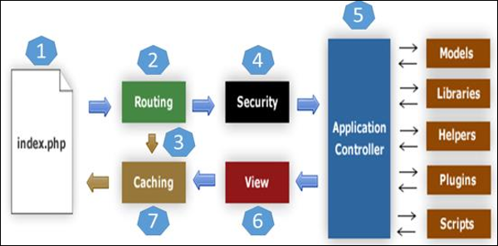

As you can see, it is possible to load strictly what we need for a specific Route, with no extra classes or object. This is the reason CodeIgniter has a very low memory usage and is very fast.

Composer can also be used together with any library if an even faster development of the project is desired. As mentioned above, one of the framework's strengths is the documentation. Here you can find all the information necessary for the project development, from A to Z: <https://codeigniter.com/user_guide/index.html>.

1. **Ajax**

* Ajax refers to JavaScript and XML, technologies that are widely used for creating dynamic and asynchronous web content. While Ajax is not limited to JavaScript and XML technologies, more often than not they are used together by web applications.
* The focus of this tutorial is on using JavaScript based Ajax functionality in Java Server Faces web applications.
* JavaScript is a dynamic scripting language for web applications.
* It allows users to add enhanced functionality to user interfaces and allows web pages to interact with clients asynchronously.
* JavaScript runs mainly on the client side (as in a browser) and thereby reduces server access by clients.
* When a JavaScript function sends an asynchronous request from the client to the server, the server sends back a response that is used to update the page's Document Object Model (DOM).
* This response is often in the format of an XML document. The term Ajax refers to this interaction between the client and server.
* The server response need not be in XML only, it can also be in other formats, such as JSON. This tutorial does not focus on the response formats.
* Ajax enables asynchronous and partial updating of web applications.
* Such functionality allows for highly responsive web pages that are rendered in near real time.
* Ajax-based web applications can access server and process information and can also retrieve data without interfering with the display and rendering of the current web page on a client (such as a browser).]
* **Some of the advantages of using Ajax are as follows:**
* Form data validation in real time, eliminating the need to submit the form for verification.
* Enhanced functionality for web pages, such as user name and password prompts.
* Partial update of the web content, avoiding complete page reloads.

1. **jQuery**

* jQuery, at its core, is a Document Object Model (DOM) manipulation library.
* The DOM is a tree-structure representation of all the elements of a Web page jQuery simplifies the syntax for finding, selecting, and manipulating these DOM elements.
* For example, jQuery can be used for finding an element in the document with a certain property (e.g. all elements with an h1 tag), changing one or more of its attributes (e.g. color, visibility), or making it respond to an event.
* jQuery also provides a paradigm for event handling that goes beyond basic DOM element selection and manipulation.
* The event assignment and the event callback function definition are done in a single step in a single location in the code.
* jQuery also aims to incorporate other highly used JavaScript functionality.

1. **MySQL**

* MySQL is a relational database management system (RDBMS) released under the GNU General Public License (GPL).
* It is one of the most widely used open-source database systems, and is compatible with a multitude of website applications.
* Dream Host also offers SQLite on Dream Host VPS and Dedicated servers.
* MYSQL is written in Cand C++. Its SQL parser is written in yacc, but it uses a home-brewed lexical analyzer. MySQL works on many system platforms, Including AIX, BSDi, FreeBSD, HP- UX, eComStation, i5/OS, IRIX, Linux, macOS, Microsoft Windows, NetBSD, Novell NetWare, OpenBSD, OpenSolaris, OS/2 Warp. QNX, Oracle Solaris, Symbian, SunOS, SCO OpenServer, SCO UnixWare, Sanos and Tru64. A port of MySQL to OpenVMS also exists.
* The MySQL server software itself and the client libraries use dual- licensing distribution.
* They are offered under GPL version 2, beginning from 28 June 2000 (which in 2009 has been extended with a FLOSS License Exception) or to use proprietary license.
* Support can be obtained from the official manual. Free support additionally is available in different IRC channels and forums.
* Oracle offers paid support via its MySQL Enterprise products.
* **MYSQL Features**
* Relational Database Management System (RDBMS)
* MySQL is a relational database management system.
* Easy to use
* MySQL is easy to use. You have to get only the basic knowledge of SQL.
* You can build and interact with MySQL with only a few simple SQL statements.
* It is secure
* MySQL consist of a solid data security layer that protects sensitive data from intruders.
* Passwords are encrypted in MySQL.
* Client/ Server Architecture
* MySQL follows a client /server architecture.
* There is a database server (MySQL) and arbitrarily many clients (application programs), which communicate with the server, that is, they query data, save changes, etc.
* Free to download

1. **CSS**

* CSS stands for Cascading Style Sheets. CSS describes how HTML elements are to be displayed on screen, paper, or in other media.CSS saves a lot of work.
* It can control the layout of multiple web pages all at once, External style sheets are stored in CSS files.
* Cascading Style Sheets (CSS) is a simple mechanism for adding style (e.g., fonts, colors, and spacing) to Web documents. These pages contain information on how to learn and use CSS and on available software.
* Cascading Style Sheets (CSS) is a style sheet language used for describing the presentation of a document written in a markup language Although most often used to set the visual style of web pages and user interfaces written in HTML and XHTML, the language can be applied to any XML document, including plain XML, SVG and XUL, and is applicable to rendering in speech, or on other media.
* Along with HTML and JavaScript, CSS is a cornerstone technology used by most websites to create visually engaging web pages, user interfaces for web applications, and user interfaces for many mobile applications.
* Separation of formatting and content makes it possible to present the same mark-up page in different styles for different rendering methods, such as onscreen, in print, by voice (via speech-based browser or screen reader), and on Braille-based tactile devices.
* It can also display the web page differently depending on the screen size or viewing device. Readers can also specify a different style sheet, such as CSS file stored on their own computer, to override the one author specified.
* Changes to the graphic design of a document (or hundreds of documents) can be applied quickly and easily, by editing a few lines in the CSS file they use, rather than by changing mark-up in the documents.
* The CSS specification describes a priority scheme to determine which style rules apply if more than one rule matches against a particular element.
* In this so-called cascade. priorities (or weights) are calculated and assigned to rules, so that the results are predictable.
* CSS is designed primarily to enable the separation of presentation and content, including aspects such as the layout, colors, and fonts.
* This separation can improve content accessibility, provide more flexibility and control in the specification of presentation characteristics, and enable multiple HTML pages to share formatting by specifying the relevant CSS in a separate.
* CSS file, and reduce complexity and repetition in the structural content.

1. **Java-Script**

* JavaScript is a multi-paradigm, dynamic language with types and operators, standard built-in objects, and methods. Its syntax is based on the Java and C languages - many structures from those languages apply to JavaScript as well.
* JavaScript supports object-oriented programming with object prototypes, instead of classes (see more about prototypical inheritance and ES2015 classes).
* JavaScript also supports functional programming - functions are objects, giving functions the capacity to hold executable code and be passed around like any other object.
* Let's start off by looking at the building blocks of any language: the types. JavaScript programs manipulate values, and those values all belong to a type.
* **JavaScript's types are:**
* Number
* String
* Boolean
* Function
* Object
* Symbol

1. **WAMP SERVER**

* Wamp Server refers to a software stack for the Microsoft Windows operating system, created by Romain Bourdon and consisting of the Apache web server, OpenSSL for SSL support, MySQL database and PHP programming language.
* WampServer is a Web development platform on Windows that allows you to create dynamic Web applications with Apache2, PHP, MySQL and MariaDB. Wamp Server automatically installs everything you need to intuitively develop Web applications. You will be able to tune your server without even touching its setting files. Best of all, WampServer is available for free (under GPML license) in both 32-bit and 64-bit versions. WampServer is not compatible with Windows XP, SP3, or Windows Server 2003.
* **Features**
* Manage your Apache, MySQL and MariaDB services
* Install and switch Apache, MySQL, MariaDB and PHP releases
* Manage your server’s settings
* Access your logs
* Access your settings files
* Create alias

# System Analysis

## System Planning

* To develop a web application, it is most important to identify the user requirements in very specific manner. The correct system is that satisfied all users requirements. Therefore, it is very important to analyse the existing system and to document the software requirement specification for proposed system, which in turn provides the base for development of the proposed system.
* Along with our technical training, we simultaneously started the system study and analysis. During this phase, initially, we started with studying the system specification documents to understand the system and unveil the basic system elements involved.

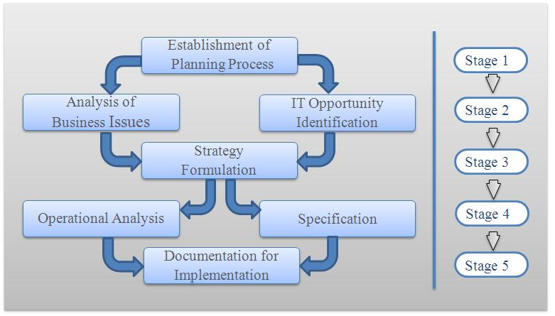

## Time Line Chart

When scheduling of a software project is done, the planner begins with a set of tasks to be performed .if automated tools are used, the work breakdown is input as a task network or task outline .Effort, duration and start date are then input for each task.in addition, tasks may be assigned to specific individuals.

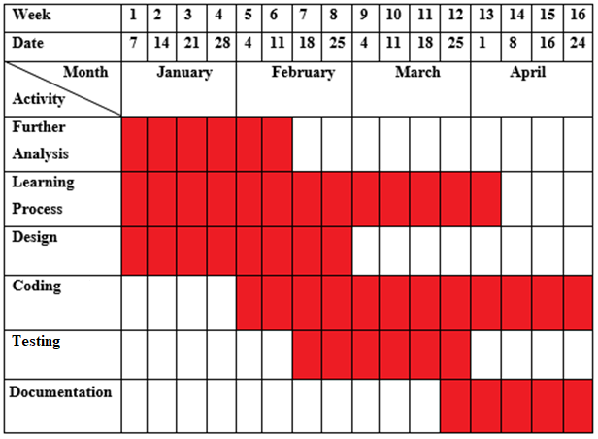

# System Analysis

## Database Design

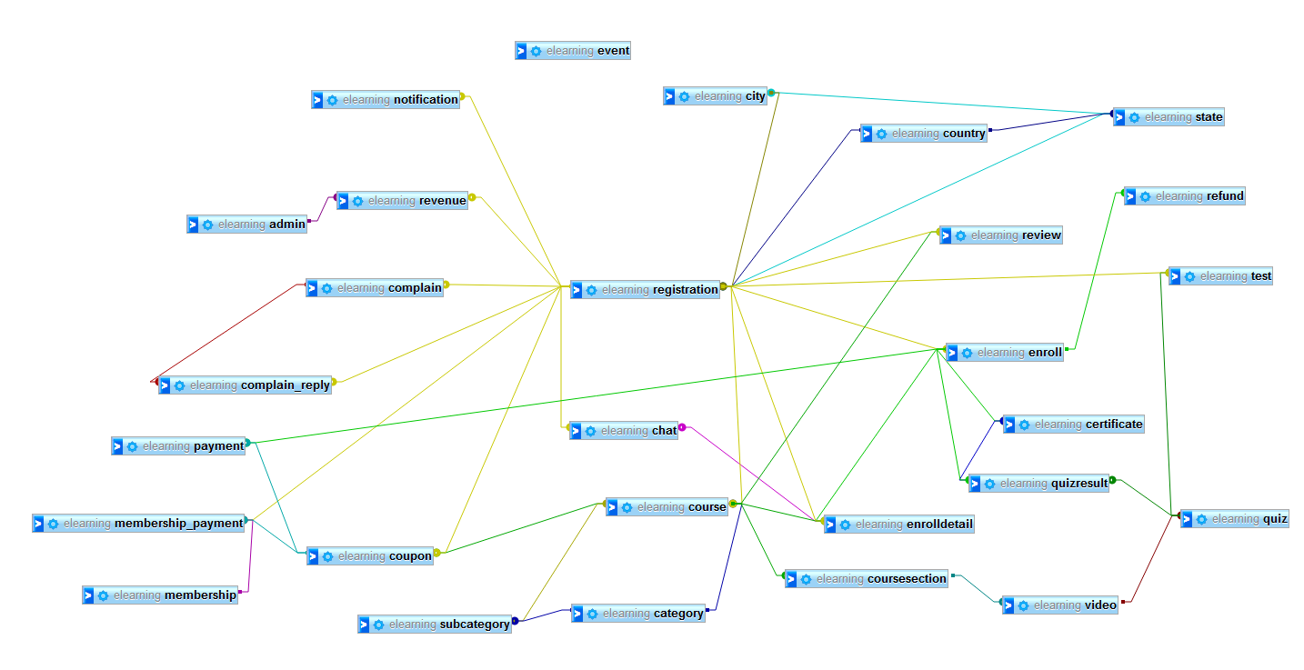

## ER Diagram

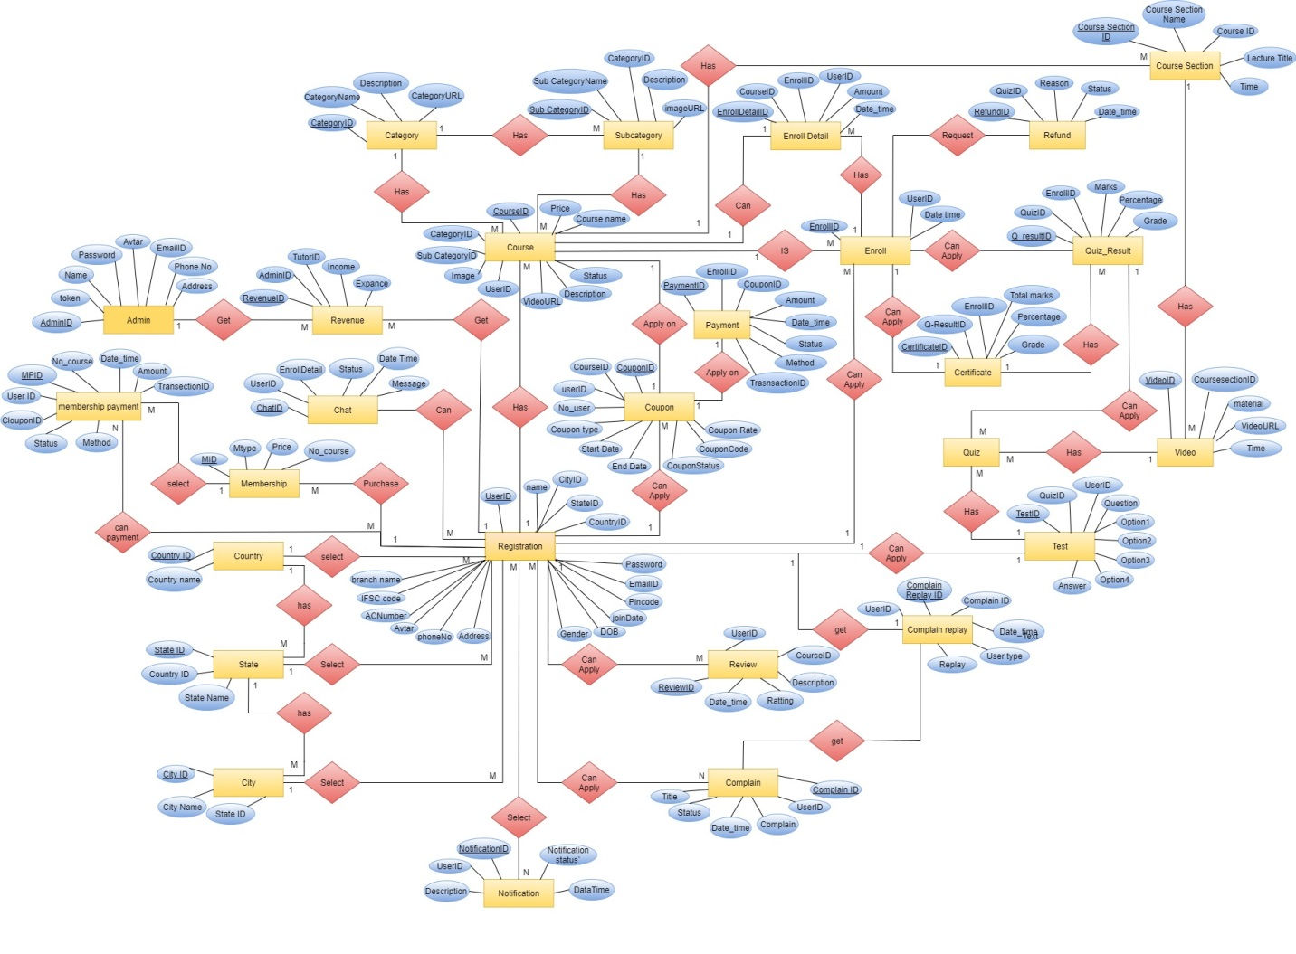

## Data Flow Diagram

* A Graphical Representation that depicts information flow and the transformation those are applied as data moves from input to output known as Data Flow Diagram.
* The DFD is also known as bubble chart the DFD may be partitioned into levels that represent increasing information flow and functional details.
* The 0th level DFD represent the Entire software elements as single bubble. As the 0th level DFD is partitioned, additional process is brought out to level more details.
* **Symbols**

External Entity

Data Store

Process

Data Flow

**Context Level Diagram**

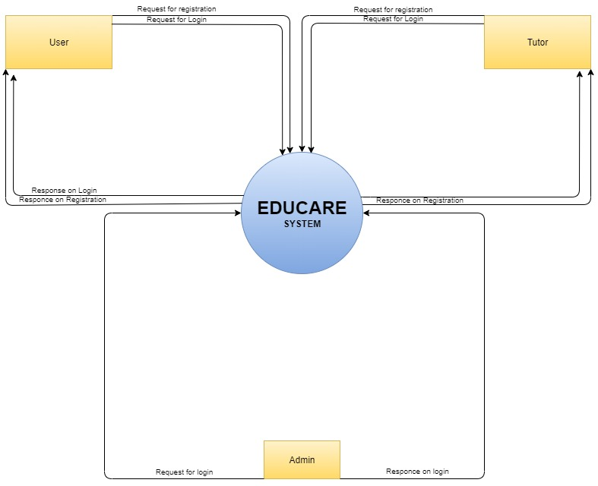

**Level – 0 Data Flow Diagram of Educare System**

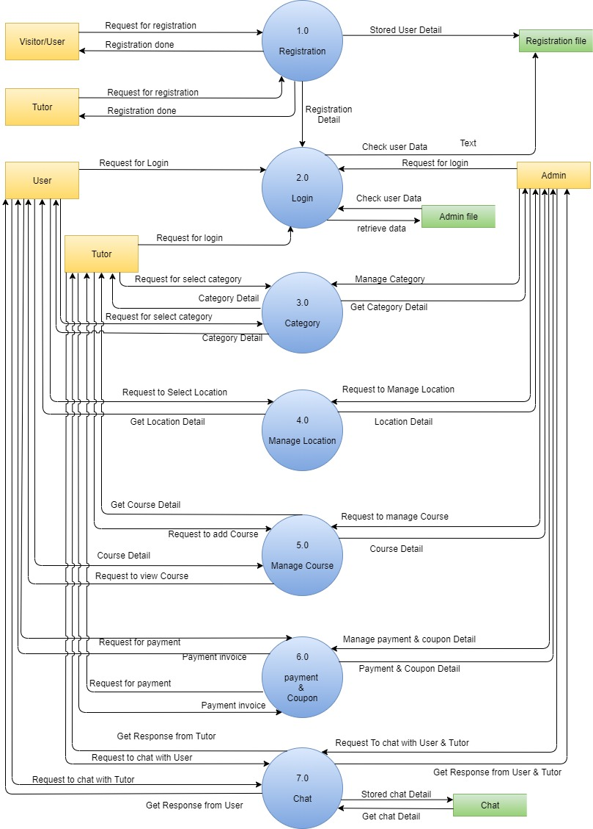

**Level – 0 Data Flow Diagram of Educare System**

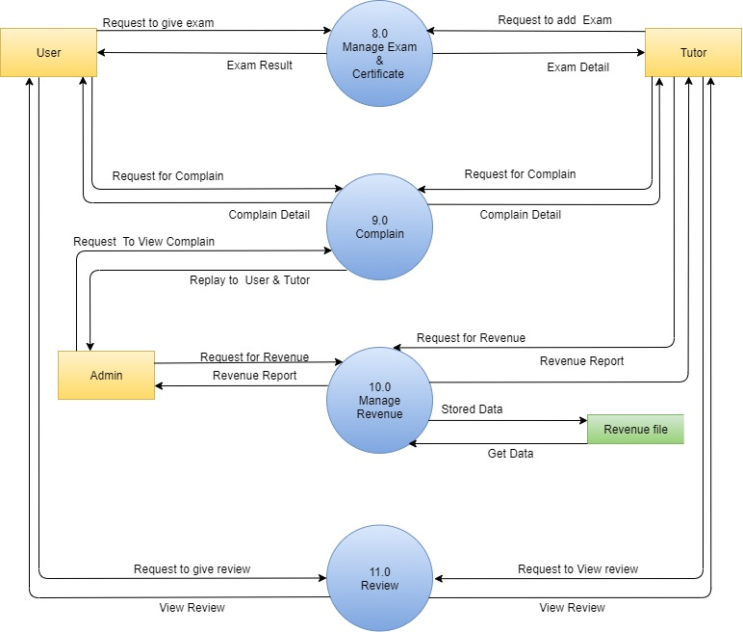

**Level – 1 Data Flow Diagram of Process 2.0 Login**

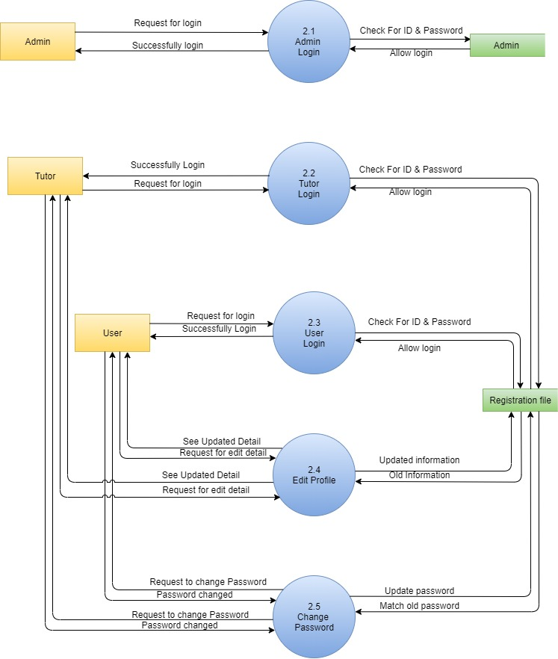

**Level – 1 Data Flow Diagram of Process 3.0 Category**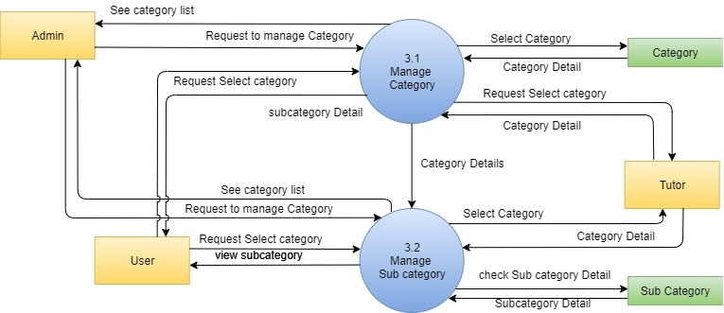

**Level – 1 Data Flow Diagram of Process 4.0 Location**

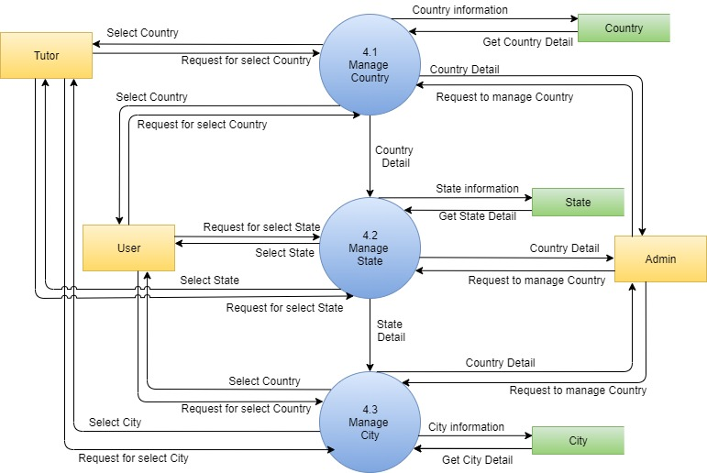

**Level – 1 Data Flow Diagram of Process 5.0 Manage Course**

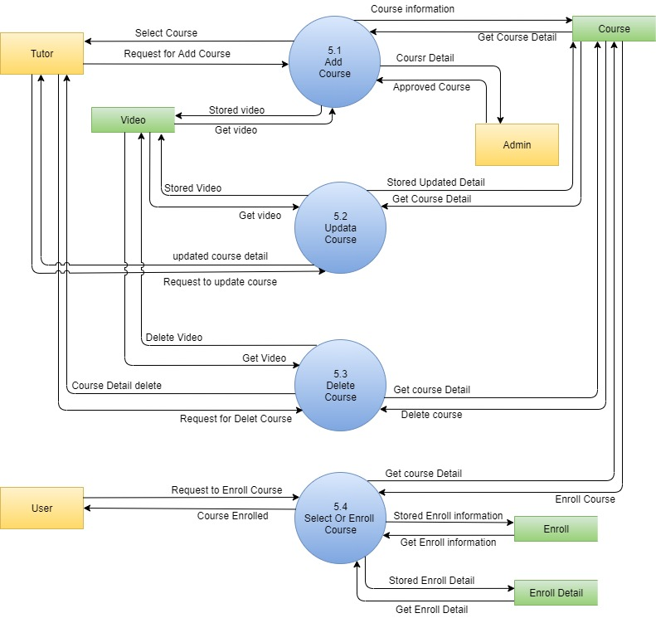

**Level – 1 Data Flow Diagram of Process 6.0 Payment & Coupon**

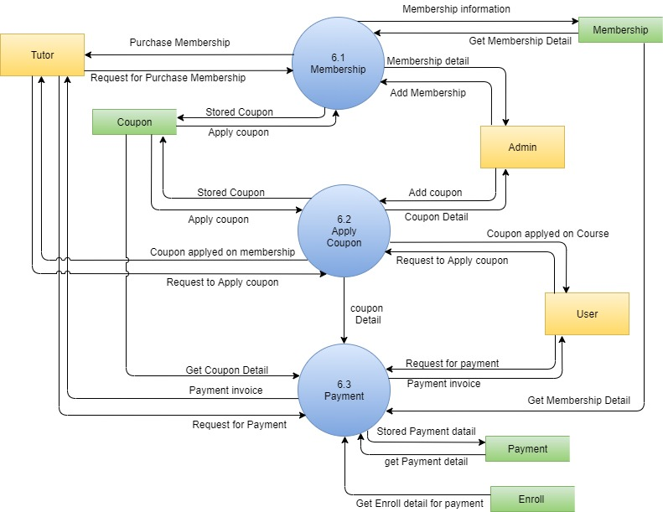

**Level – 1 Data Flow Diagram of Process 2.0 Manage Exam & Certificate**

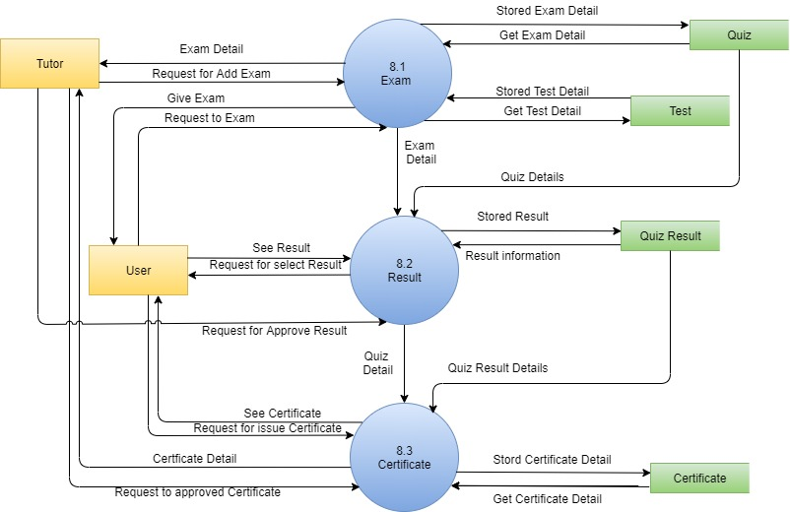

## Process Specification

|  |  |
| --- | --- |
| Process name | Registration |
| Process No | 1.0 |
| Input | Registration Detail |
| Output | current Registration Detail |
| Logic | For The register user the data like name, email id and other will accepted and stored it into User and same process will repeat other users. |

|  |  |
| --- | --- |
| Process name | Login |
| process No | 2.0 |
| Input | Login Detail |
| Output | valid/invalid login detail |
| Logic | For the login user will enter its username and password it's fetched from User. If the data invalid its show error message if valid then redirect to its respected page. same process repeat for other user |

|  |  |
| --- | --- |
| process name | Admin Login |
| process No | 2.1 |
| Input | Admin login detail |
| Output | valid/invalid login detail |
| Logic | For the login admin will enter its username and password it's fetched from Admin. If the data invalid it's show error message if valid then redirect to its respected page. |

|  |  |
| --- | --- |
| Process name | Tutor Login |
| process No | 2.2 |
| Input | Login Detail |
| Output | valid/invalid login detail |
| Logic | For the login user will enter its username and password it's fetched from User. If the data invalid it's show error message if valid then redirect to its respected page. same process repeat for other user |

|  |  |
| --- | --- |
| Process name | User Login |
| process No | 2.3 |
| Input | Login Detail |
| Output | valid/invalid login detail |
| Logic | For the login user will enter its username and password it's fetched from User. If the data invalid it's show error message if valid then redirect to its respected page. same process repeat for other user |

|  |  |
| --- | --- |
| Process name | Edit Profile |
| process No | 2.4 |
| Input | User Profile detail |
| Output | User profile will update |
| Logic | User will be editing the detail of the all photos of other detail and stored it in database and same process repeated for the other user. |

|  |  |
| --- | --- |
| Process name | Change Password |
| process No | 2.5 |
| Input | Password detail |
| Output | User password changed |
| Logic | User will be change the password and stored it in database as encrypted format and same process repeated for the admin,Tutor. |

|  |  |
| --- | --- |
| Process name | Category |
| process No | 3.0 |
| Input | Category detail |
| Output | Current Category detail |
| Logic | Admin will be add the detail of the all category for course and stored it in category and same process repeated for the other category. |

|  |  |
| --- | --- |
| Process name | Manage Category |
| process No | 3.1 |
| Input | Manage Category detail |
| Output | Current category Detail |
| Logic | Admin will be manage the detail of the category and stored it in category and same process repeated for the other category. |

|  |  |
| --- | --- |
| Process name | Manage Subcategory |
| process No | 3.2 |
| Input | Subcategory detail |
| Output | Current Subcategory Detail |
| Logic | Admin will be manage the detail of the Subcategory and stored it in Subcategory and same process repeated for the other Subcategory. |

|  |  |
| --- | --- |
| Process name | Location |
| process No | 4.0 |
| Input | Location detail |
| Output | Location detail |
| Logic | The Admin will be giving the location and location will be select by the user and same process will repeated for the other users. |

|  |  |
| --- | --- |
| Process name | Manage Country |
| process No | 4.1 |
| Input | Country detail |
| Output | Current Country detail |
| Logic | The Admin will be giving the Country and it will be select by the user and same process will repeat for the other users. |

|  |  |
| --- | --- |
| Process name | Manage State |
| process No | 4.2 |
| Input | State Detail |
| Output | Current State Detail |
| Logic | The Admin will be giving the State and it will be select by the user and same process will repeat for the other users. |

|  |  |
| --- | --- |
| Process name | Manage City |
| process No | 4.3 |
| Input | City Detail |
| Output | Current city Detail |
| Logic | The Admin will be giving the city and it will be select by the user and same process will repeat for the other users. |

|  |  |
| --- | --- |
| Process name | Manage Course |
| process No | 5.0 |
| Input | Course Detail |
| Output | Current Course Detail |
| Logic | The Tutor will be add course and it will be select by the user and same process will repeat for the other users. |

|  |  |
| --- | --- |
| Process name | Add Course |
| process No | 5.1 |
| Input | New Course Detail |
| Output | Newly Added Course Detail |
| Logic | The Tutor will be add course and it will be select by the user and same process will repeat for the other users. |

|  |  |
| --- | --- |
| Process name | Edit Course |
| process No | 5.2 |
| Input | Course Detail |
| Output | Updated Course Detail |
| Logic | The Tutor will be Update course and it will be select by the user and same process will repeat for the other users. |

|  |  |
| --- | --- |
| Process name | Delete Course |
| process No | 5.0 |
| Input | Course Detail |
| Output | Current Course was deleted |
| Logic | The Tutor will be deleting course and the admin will give approved. |

|  |  |
| --- | --- |
| Process name | Payment & Coupon |
| process No | 6.0 |
| Input | Course Detail |
| Output | Payment invoice |
| Logic | The User will make payment and amount directly add in admin bank account and user will received Invoice. |
| Process name | **Payment & Coupon** |
| process No | 6.1 |
| Input | Membership Detail |
| Output | Membership invoice |
| Logic | The User will make payment for Membership and amount directly add in admin bank account and user will received Invoice. |

|  |  |
| --- | --- |
| Process name | Apply Coupon |
| process No | 6.2 |
| Input | Coupon Detail |
| Output | Current coupon detail |
| Logic | The User will make payment for and apply coupon and get discount, |

|  |  |
| --- | --- |
| Process name | Payment |
| process No | 6.3 |
| Input | Coupon Detail |
| Output | Current coupon detail |
| Logic | The User will make payment for and apply coupon and get discount, |

|  |  |
| --- | --- |
| Process name | Chat |
| process No | 7.0 |
| Input | Chat Detail |
| Output | Display chat detail |
| Logic | User will Chat with the Tutor and explain their Problem related to the course. And Tutor will solve the problem of the user |

|  |  |
| --- | --- |
| Process name | Complain |
| process No | 9.0 |
| Input | Complain Detail |
| Output | Display Complain detail |
| Logic | User can complain Related to the website or they discuss their problem which they are facing on website. |

|  |  |
| --- | --- |
| Process name | Manage Revenue |
| process No | 10.0 |
| Input | Revenue Detail |
| Output | Display Revenue detail |
| Logic | The Admin & Tutor Will get Revenue Report and get the record of their income and expanse |

|  |  |
| --- | --- |
| Process name | Review |
| process No | 11.0 |
| Input | Review Detail |
| Output | Display Review detail |
| Logic | The User will give review on the course and they also give Ratting, it was very helpful to the Tutor so they improve their course |

## Data Dictionary

**Table Name**: admin

**Purpose**: Stored information of admin.

|  |  |  |  |  |
| --- | --- | --- | --- | --- |
| Column Name | Datatype | Null | Constraints | Description |
| AdminID | Int (11) | No | Primary key | Unique identity key for admin |
| Password | Varchar (50) | No |  | Admin Password |
| Name | Varchar (30) | No |  | Stored name of admin |
| EmailID | Varchar (50) | No |  | It will be stored Email ID of admin |
| Avtar | Text | No |  | Admin Profile Image |
| Address | Varchar (50) | No |  | Stored Address of Admin |
| PhoneNo | Bigint (10) | No |  | Admin Contact number |
| token | Varchar () | No |  | Used while admin forget password |

**Table Name**: Category

**Purpose**: Stored information of category details.

|  |  |  |  |  |
| --- | --- | --- | --- | --- |
| Column Name | Datatype | Null | Attributes | Description |
| CategoryID | Int (11) | - | Primary key | Unique identity key for category |
| CategoryName | Varchar (30) | No |  | It will hold the category name |
| Description | Text | No |  | It will store the description for category |
| CategoryURL | Varchar (50) | No |  | It will be stored image of category |

**Table Name**: Certificate

**Purpose**: Stored information of all users Certificate.

|  |  |  |  |  |
| --- | --- | --- | --- | --- |
| Column Name | Datatype | Null | Attributes | Description |
| CertificateID | Int(11) | - | Primary key | Unique id for Certificate |
| Q_Result | Int(11) | No | Foreign Key | Foreign Key of QuizResult table |
| EnrollID | Int(11) | No | Foreign Key | Foreign Key of Enroll table |
| TotalMarks | Int(10) | No |  | Total marks of user |
| Percentage | Int(5) | No |  | Percentage of user |
| Grade | Varchar(5) | No |  | Grade of particular user |

**Table Name**: Chat

**Purpose**: Stored information of all Chat.

|  |  |  |  |  |
| --- | --- | --- | --- | --- |
| Column Name | Datatype | Null | Attributes | Description |
| ChatID | Int(11) | - | Primary key | Unique key of Chat |
| UserID | Int(11) | No |  | User id for chatting |
| TutorID | Int(11) | No |  | Tutor id for chatting |
| Message | Text | No |  | Massage of chatting |
| Status | Int(5) | No |  | Chatting status |
| Date_Time | Datetime | No |  | Time of chat |

**Table Name**: City

**Purpose**: Stored information of City

|  |  |  |  |  |
| --- | --- | --- | --- | --- |
| Column Name | Datatype | Null | Attributes | Description |
| CityID | Int(11) | - | Primary key | Unique key for city |
| StateID | Int(11) | No |  | State key from state table |
| CityName | Varchar(15) | No |  | Stored city name |

**Table Name**: Complain

**Purpose**: Stored information of booking

|  |  |  |  |  |
| --- | --- | --- | --- | --- |
| Column Name | Datatype | Null | Attributes | Description |
| ComplainID | Int(11) | - | Primary key | Unique key for Complain |
| UserID | Int(11) | No |  | Which user make complain |
| Complain | Text | No |  | Complain detail |
| Status | Varchar(10) | No |  | Complain status |
| Date_Time | datetime | No |  | Complain date and time |

**Table Name**: Country

**Purpose**: Stored information about Country.

|  |  |  |  |  |
| --- | --- | --- | --- | --- |
| Column Name | Datatype | Null | Attributes | Description |
| countryID | Int(11) | - | Primary key | Unique key for country |
| countryName | Varchar(15) | No |  | Stored country name |

**Table Name**: Course

**Purpose**: Stored information of coupon.

|  |  |  |  |  |
| --- | --- | --- | --- | --- |
| Column Name | Datatype | Null | Attributes | Description |
| CouresID | Int(11) | - | Primary key | Unique id of course |
| CategoryID | Int(11) | No |  | Category of course |
| SubCategoryID | Int(11) | No |  | Subcategory of course |
| UserID | Int(11) | No |  | User who upload course |
| CourseName | Varchar(30) | No |  | Name of particular course |
| Price | Int(10) | No |  | The price of course |
| Description | Text | No |  | Description of course |
| Status | Int(5) | No |  | Status of course |
| Image | Text | No |  | Course image |
| VideoURL | Text | No |  | Video of course |

**Table Name**: CourseImage

**Purpose**: Stored information of courseimage.

|  |  |  |  |  |
| --- | --- | --- | --- | --- |
| Column Name | Datatype | Null | Attributes | Description |
| ImageID | Int(11) | - | Primary key | Unique key for image |
| CourseID | Int(11) | No |  | Image for particular course |
| ImageURL | Text | No |  | Image for particular course |

**Table Name**: Coursesection

**Purpose**: Stored information of coursesection.

|  |  |  |  |  |
| --- | --- | --- | --- | --- |
| Column Name | Datatype | Null | Attributes | Description |
| CourseSectionID | Int(11) | - | Primary key | Unique key for |
| CourseSectionName | Varchar(50) | No |  | Course section name |
| CourseID | Int(11) | No |  | ID of Course |
| Lecture Title | Text | No |  | Lecture of Course |
| Time | Time | No |  | Duration of video |

**Table Name**: Enroll

**Purpose**: Stored detail of user who enrol course.

|  |  |  |  |  |
| --- | --- | --- | --- | --- |
| Column Name | Datatype | Null | Attributes | Description |
| EnrollID | Int(11) | - | Primary key | Unique key for Enroll |
| UserID | Int(11) | No |  | Which user was enrol Course |
| Date_Time | Datetime | No |  | Stored date and time |

**Table Name**: Enrolldetail

**Purpose**: Stored information of Enrolldetail

|  |  |  |  |  |
| --- | --- | --- | --- | --- |
| Column Name | Datatype | Null | Attributes | Description |
| EnrollDetailID | Int(11) | - | Primary key | Unique key for Enroll detail |
| CourseID | Int(11) | No |  | For Course detail |
| EnrollID | Int(11) | No |  | Used for access enroll data |
| Amount | Int(50) | No |  | Total Amount of course |
| Data_Time | Datetime | No |  | Stored date and time |

**Table Name**: Event

**Purpose**: Stored information of Event.

|  |  |  |  |  |
| --- | --- | --- | --- | --- |
| Column Name | Datatype | Null | Attributes | Description |
| EventID | Int(11) | - | Primary key | Unique key for Event |
| EventImage | Text | No |  | Event cover image |
| EventTitle | Varchar(30) | No |  | The title of Event |
| Description | Text | No |  | Description of Event |
| Date | Date | No |  | Event publish date |

**Table Name**: Gallery

**Purpose**: Stored information of Multiple Image Of Course in Gallery

|  |  |  |  |  |
| --- | --- | --- | --- | --- |
| Column Name | Datatype | Null | Attributes | Description |
| GalleryID | Int(11) | - | Primary key | Unique key for gallery |
| CategoryID | Int(11) | No |  | To stored category image |
| ImageURL | Text | No |  | Image of category |

**Table Name**: Membership

**Purpose**: Stored Membership detail.

|  |  |  |  |  |
| --- | --- | --- | --- | --- |
| Column Name | Datatype | Null | Attributes | Description |
| MID | Int(11) | - | Primary key | Unique key for membership |
| MType | Varchar(10) | No |  | Type of membership |
| Price | Int(5) | No |  | Price of membership plan |
| No_Course | Int(5) | No |  | How many Course they upload |

**Table Name**: Payment

**Purpose**: Stored information of Payment.

|  |  |  |  |  |
| --- | --- | --- | --- | --- |
| Column Name | Datatype | Null | Attributes | Description |
| PaymentID | Int(11) | - | Primary key | Unique key for Payment |
| EnrollIID | Int(11) | No |  | Enroll Detail |
| MID | Int(11) | No |  | Membership Payment accept |
| CouponID | Int(11) | No |  | Applied coupon code |
| Amount | Int(10) | No |  | Total amount |
| Date_Time | Datetime | No |  | Date and Time of payment |
| Status | Varchar(10) | No |  | Payment status |
| Method | Varchar(20) | No |  | Payment method |
| TransactionID | Text | No |  | Unique Id for each transaction |

**Table Name**: Quiz

**Purpose**: Stored information of quiz

|  |  |  |  |  |
| --- | --- | --- | --- | --- |
| Column Name | Datatype | Null | Attributes | Description |
| QuizID | Int(11) | - | Primary key | Unique key for Quiz |
| VideoID | Int(11) | No |  | Video of particular section |

**Table Name**: Quizresult

**Purpose**: Stored information of Quiz result

|  |  |  |  |  |
| --- | --- | --- | --- | --- |
| Column Name | Datatype | Null | Attributes | Description |
| Q_ResultID | Int(11) | - | Primary key | Unique key for Q_Result |
| QuizID | Int(11) | No |  | Show quiz |
| EnrollID | Int(11) | No |  | Enroll detail |
| Marks | Int(5) | No |  | Marks of user get |
| Percentage | Int(5) | No |  | Percentage of user |
| Grade | Varchar(5) | No |  | Stored grade of user |

**Table Name**: Refund

**Purpose**: Stored information of review

|  |  |  |  |  |
| --- | --- | --- | --- | --- |
| Column Name | Datatype | Null | Attributes | Description |
| RefundID | Int(11) | - | Primary key | Unique key for Refund |
| EnrollID | Int(11) | No |  | Enroll detail |
| Reason | Text | No |  | Reason for the refund |
| Status | Varchar(10) | No |  | Status of Refund |
| Date_Time | Datetime | No |  | Date and time where user apply for refund |

**Table Name**: Registration

**Purpose**: Stored information of User

|  |  |  |  |  |
| --- | --- | --- | --- | --- |
| Column Name | Datatype | Null | Attributes | Description |
| UserID | Int(11) | - | Primary key | Unique key for user |
| Name | Varchar(50) | No |  | User name |
| MID | Int(11) | No |  | Membership plan select by user |
| CityID | Int(11) | No |  | City select by user |
| StateID | Int(11) | No |  | State select by user |
| CountryID | Int(11) | No |  | Country select by user |
| Password | Varchar(50) | No |  | Password of user |
| EmailID | Varchar(50) | No |  | User’s email id |
| Pincode | Int(6) | No |  | Pin code of user |
| JoinDate | Datetime | No |  | User Joining date |
| DOB | Date | No |  | User date of birth |
| Gender | Varchar(5) | No |  | User gender |
| Address | Text | No |  | User address |
| PhoneNo | Bigint(10) | No |  | Contact number of user |
| Avtar | Text | No |  | User profile image |
| ACNumber | Bigint(20) | No |  | Bank account number |
| IFSCCode | Varchar(20) | No |  | IFSC code of bank |
| BranchName | Varchar(20) | No |  | Bank branch name |
| UserStatus | Varchar(10) | No |  | User status |
| ReferCode | Text | No |  | User Refer code |
| ReferedBy | Varchar(50) | No |  | Other user refer code |
| Status | Int(11) | No |  | User status |
| Point | Int(10) | No |  | User point |
| token | Varchar(20) | No |  | User token |

**Table Name**: Revenue

**Purpose**: Stored information of provider’s service

|  |  |  |  |  |
| --- | --- | --- | --- | --- |
| Column Name | Datatype | Null | Attributes | Description |
| RID | Int(11) | - | Primary key | Unique key for Revenue |
| TutorID | Int(11) | No |  | User revenue |
| AdminID | Int(11) | No |  | Admin revenue |
| Income | Int(10) | No |  | Total income |
| Expence | Int(10) | No |  | Total expence |

**Table Name**: Review  
**Purpose**: Stored information of provider’s service

|  |  |  |  |  |
| --- | --- | --- | --- | --- |
| Column Name | Datatype | Null | Attributes | Description |
| ReviewID | Int(11) | - | Primary key | Unique key for review |
| UserID | Int(11) | No |  | User who give review |
| CourseID | Int(11) | No |  | On which course user give review |
| Description | Text | No |  | Description of review |
| Ratting | Int(5) | No |  | Ratting of review |
| Date_Time | Datetime | No |  | Date and time of review |

**Table Name**: State

**Purpose**: Stored information of provider’s service

|  |  |  |  |  |
| --- | --- | --- | --- | --- |
| Column Name | Datatype | Null | Attributes | Description |
| StateID | Int(11) | - | Primary key | Unique key for State |
| CountryID | Int(11) | No |  | Country Id |
| StateName | Varchar(15) | No |  | State name |

**Table Name**: Subcategory

**Purpose**: Stored information of provider’s service

|  |  |  |  |  |
| --- | --- | --- | --- | --- |
| Column Name | Datatype | Null | Attributes | Description |
| SubCategoryID | Int(11) | - | Primary key | Unique key for subcategory |
| CategoryID | Int(11) | No |  | Category detail |
| SubCategoryName | Varchar(30) | No |  | Subcategory name |
| Description | Text | No |  | Description of subcategory |
| ImageURL | Varchar(50) | No |  | Image of subcategor |

**Table Name**: Test

**Purpose**: Stored information of provider’s service

|  |  |  |  |  |
| --- | --- | --- | --- | --- |
| Column Name | Datatype | Null | Attributes | Description |
| TestID | Int(11) | - | Primary key | Unique key for test |
| QuizID | Int(11) | No |  | Question id |
| UserID | Int(11) | No |  | User who add test |
| Question | Text | No |  | Question detail |
| Option1 | Text | No |  | Option1 detail |
| Option2 | Text | No |  | Option 2 detail |
| Option3 | Text | No |  | Option 3 detail |
| Option4 | Text | No |  | Option 4 detail |
| Answer | Int(11) | No |  | Answer detail |

**Table Name**: Video

**Purpose**: Stored information of provider’s service

|  |  |  |  |  |
| --- | --- | --- | --- | --- |
| Column Name | Datatype | Null | Attributes | Description |
| VideoID | Int(11) | - | Primary key | Unique key for video |
| CourseSectionID | Int(11) | No |  | Video for particular section |
| Material | Text | No |  | Material file |
| VideoURL | Text | No |  | Video url |
| Time | Time | No |  | Date and time for uploaded video |

# 

# Designing

## User Interface

**User Homepage**



**Contact Us**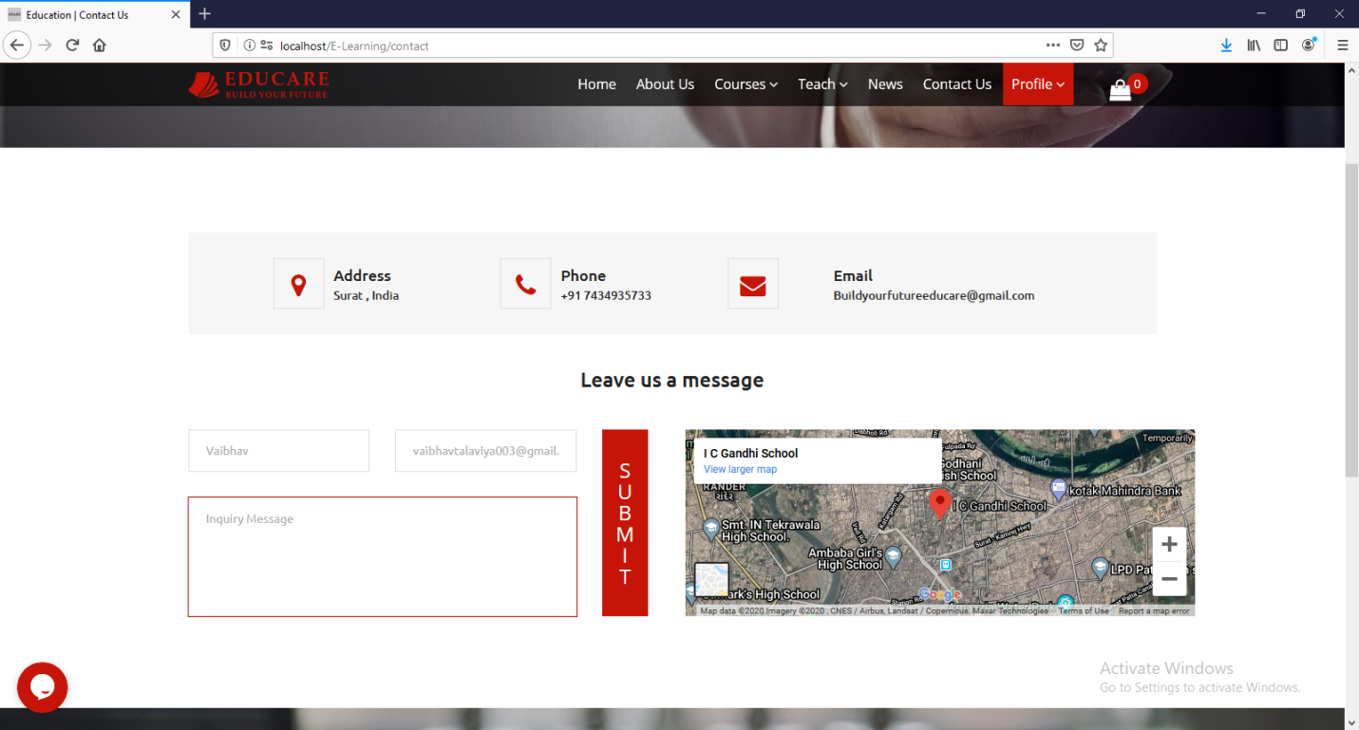

**About Us**



**Membership Plan**

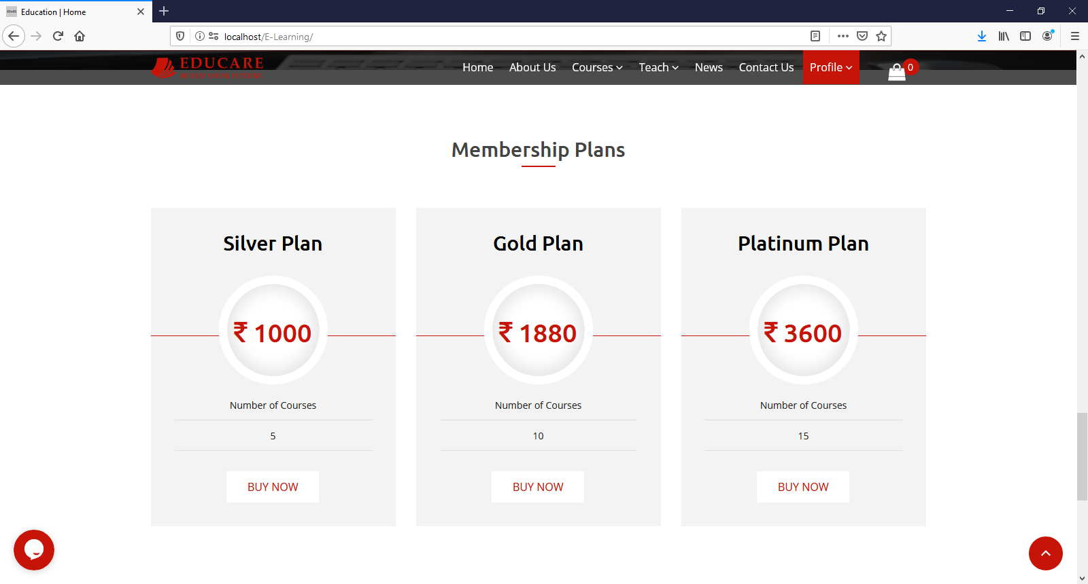

**List of Trainers**

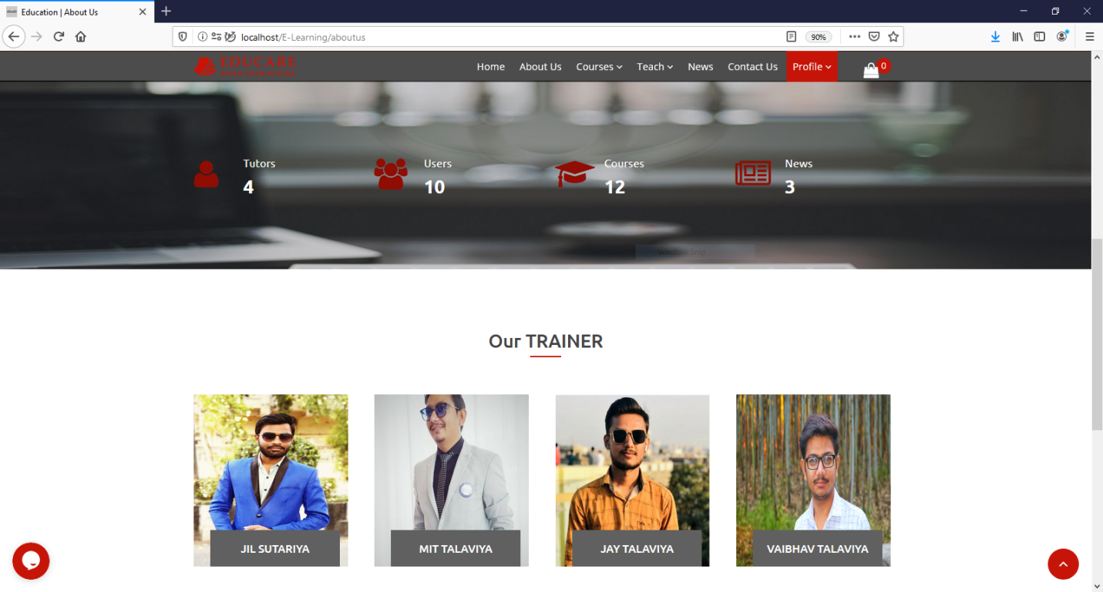

**Course Listing User Guide**



**Cart Detail**

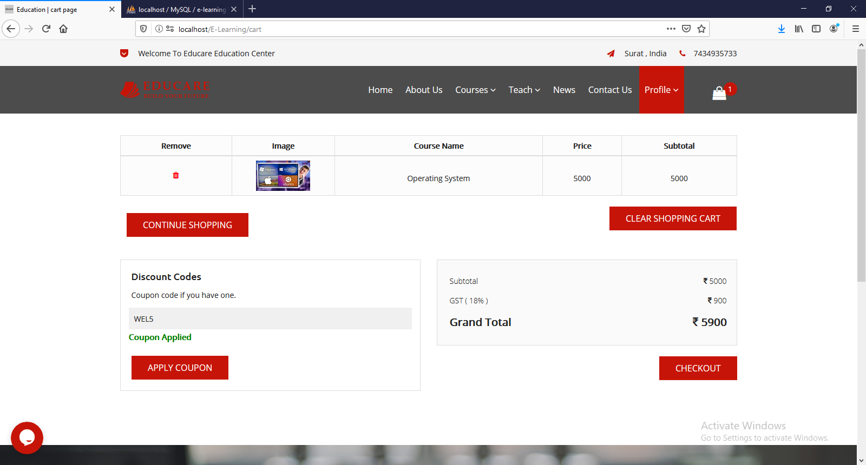

**Checkout Detail**

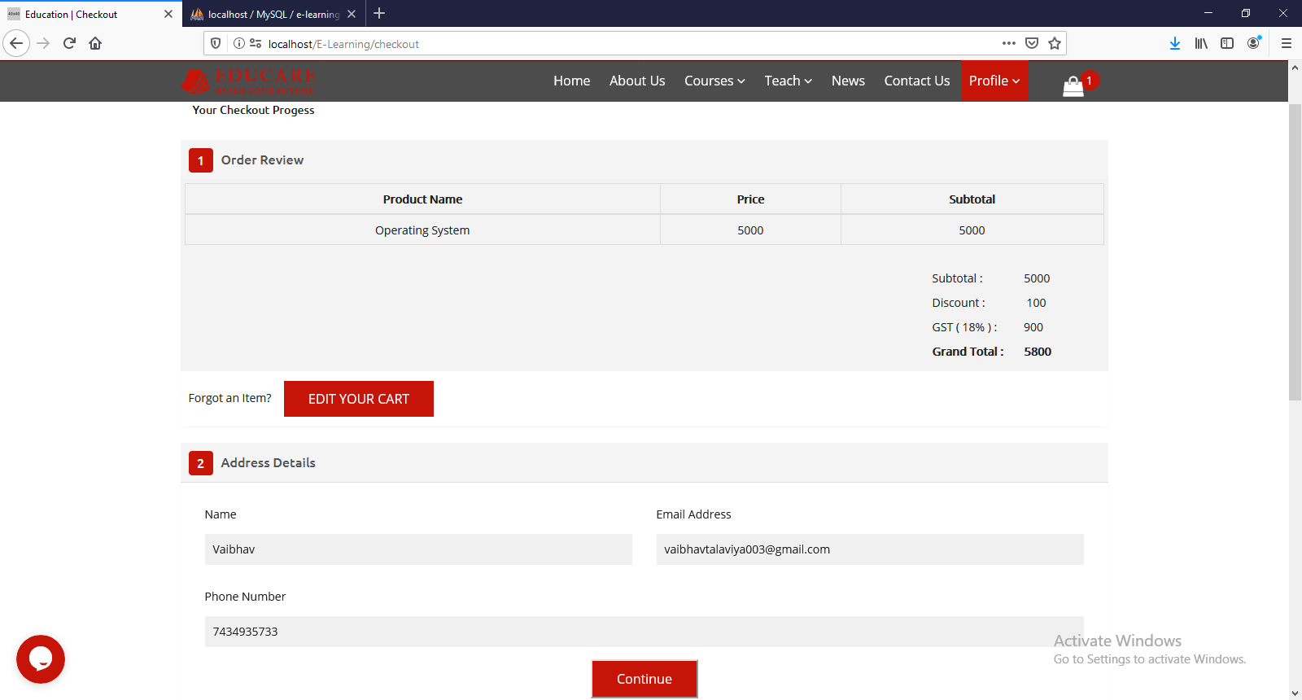

**Payment Page**

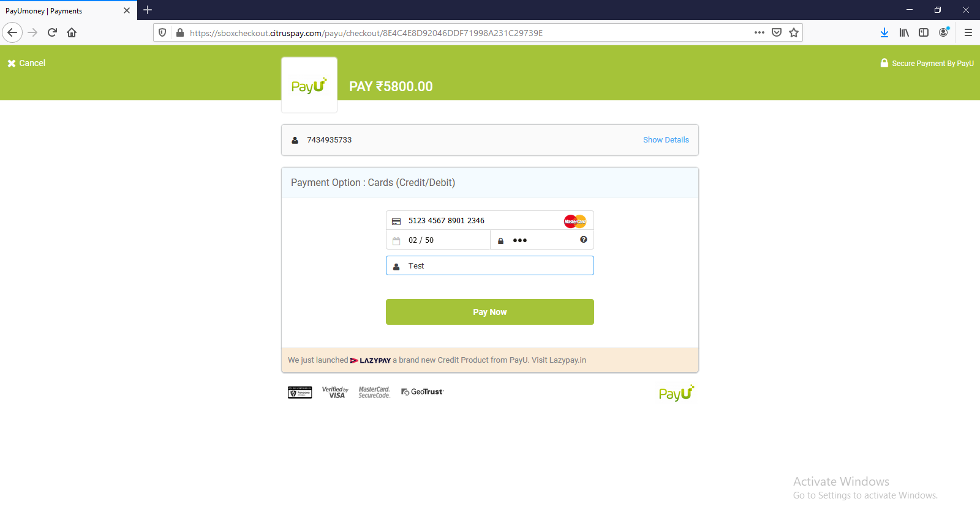

**Create Course Step: 1**

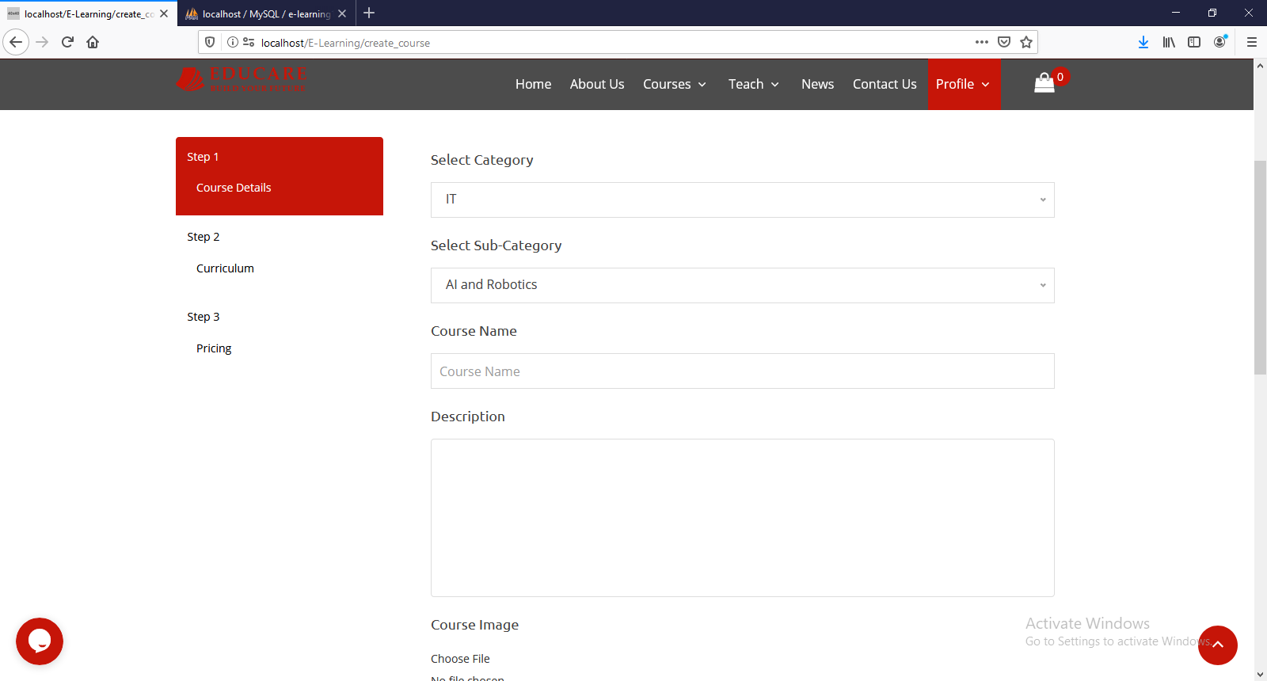

**List Of Course Upload by Tutor**

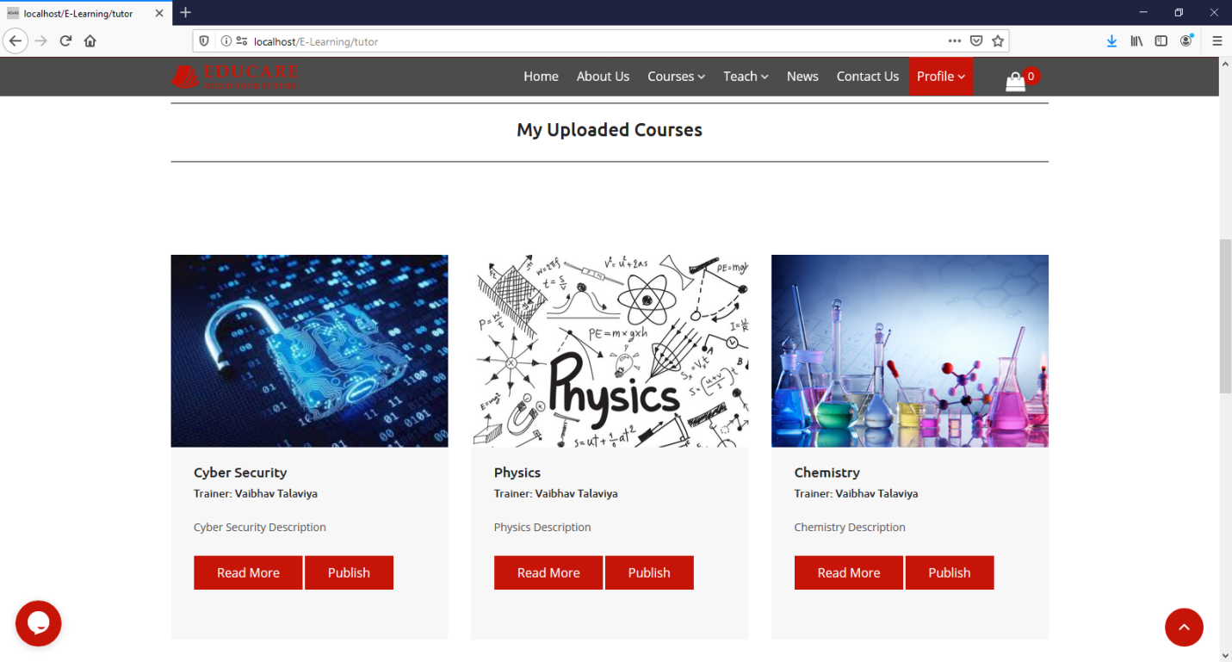

**Tutor discusses with student**

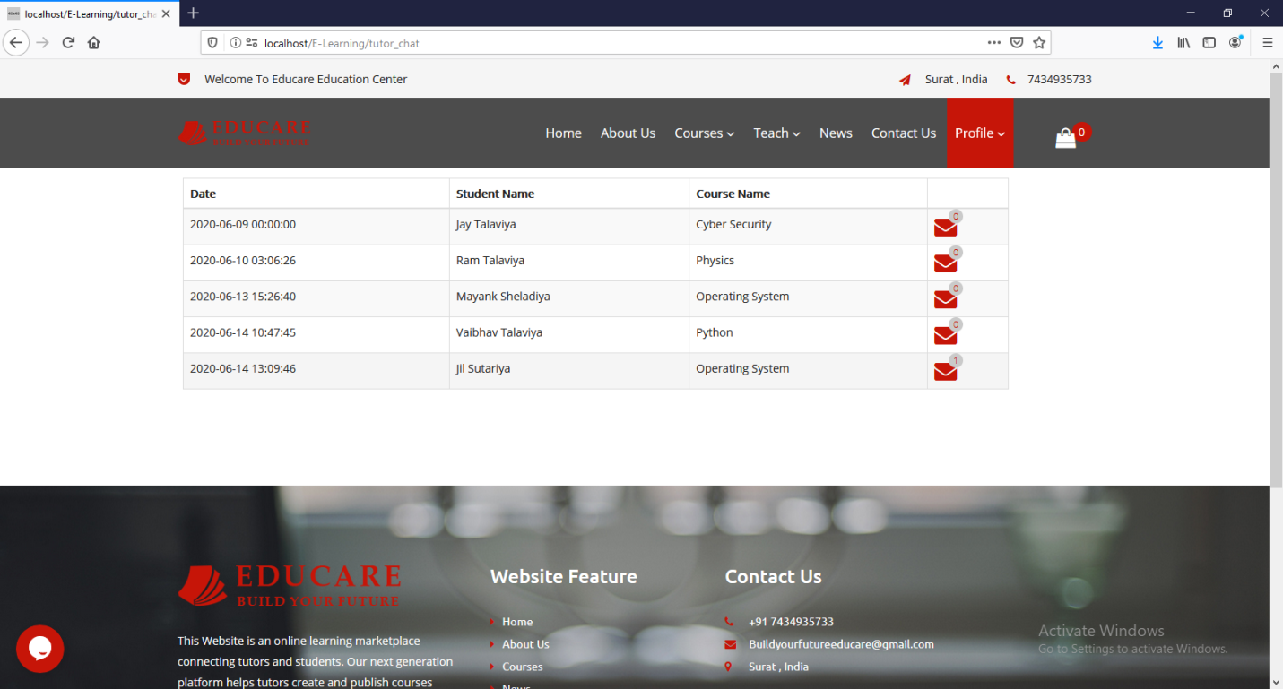

**News & Events**

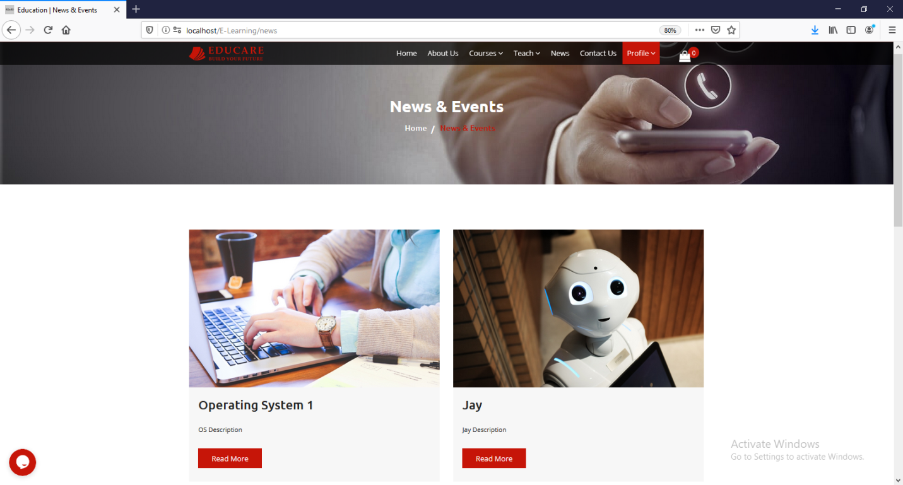

**User Profile Page**

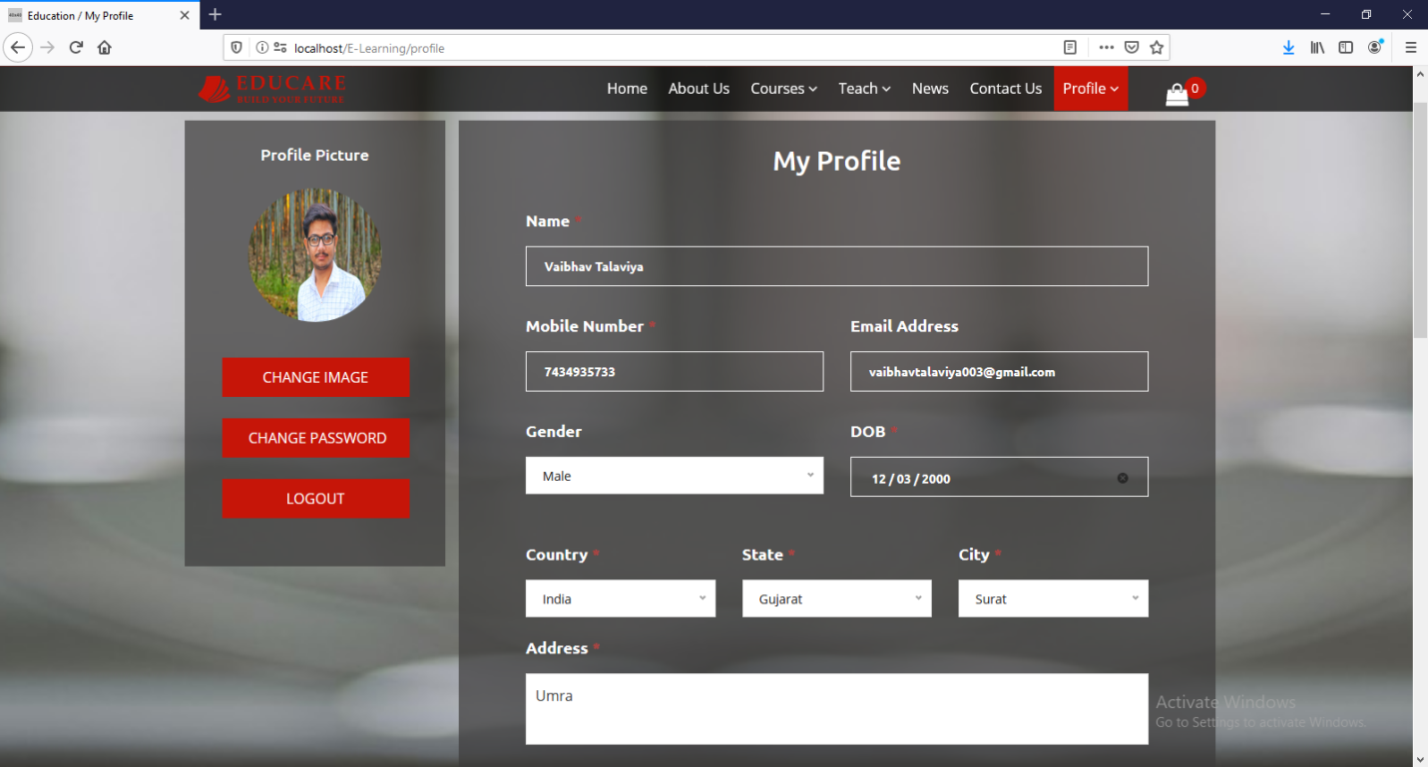

**User Purchased Course List**

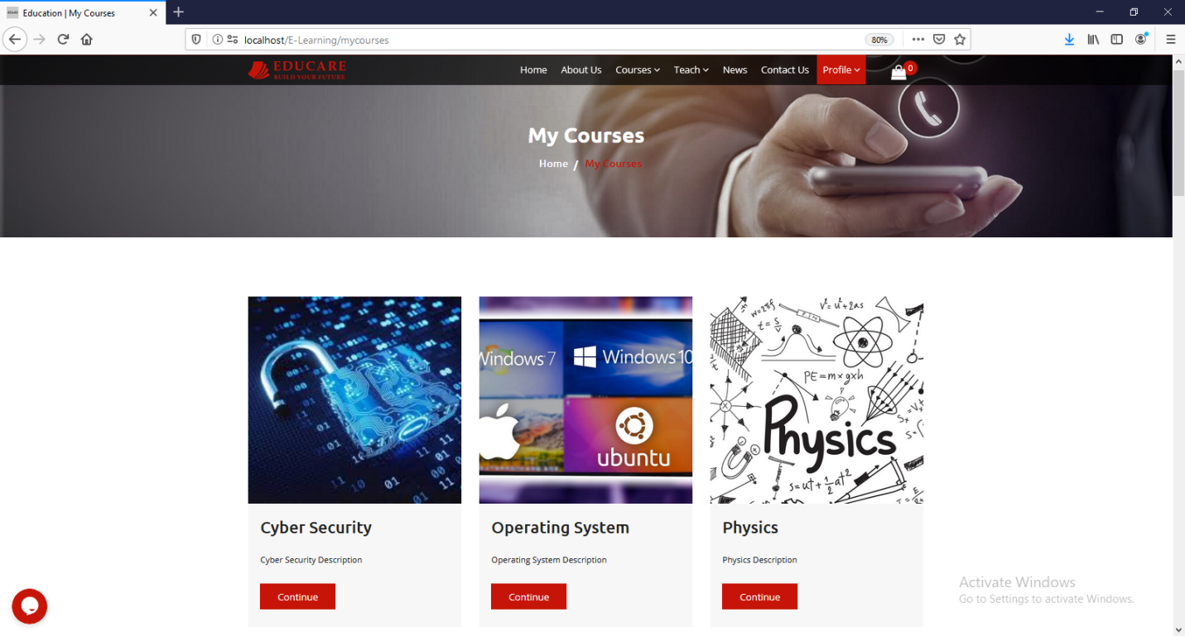

**User Can View Video Lecture for Enrolled Course**

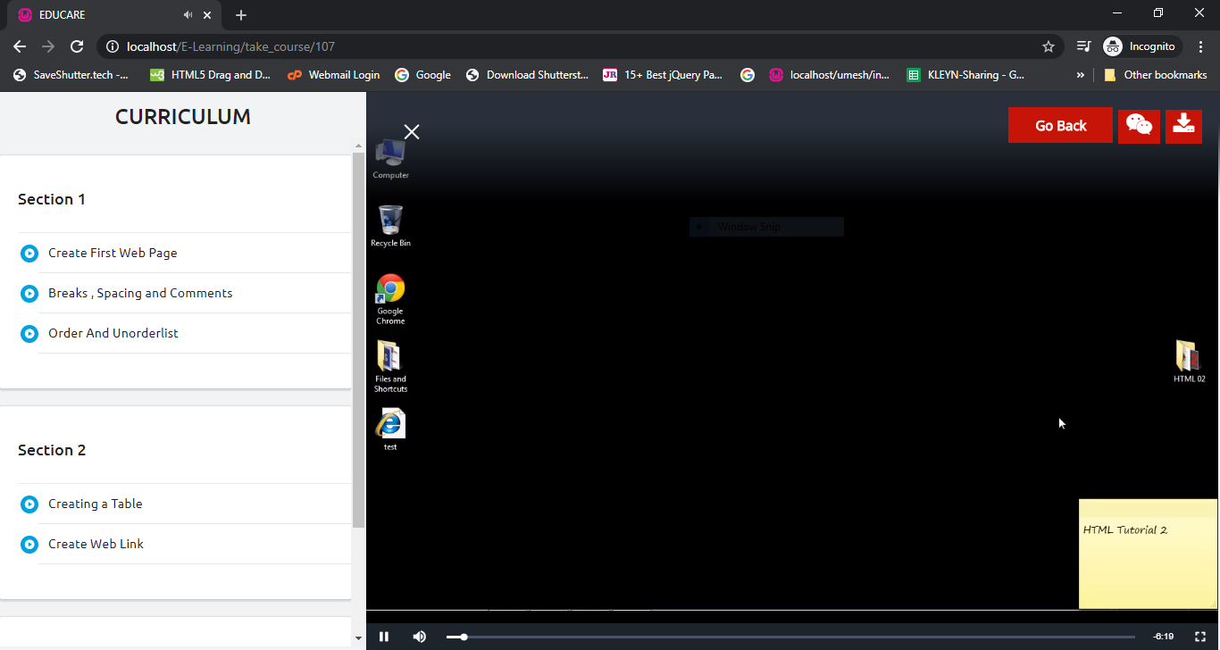

**User Have To Give Exam After View Video Lecture**

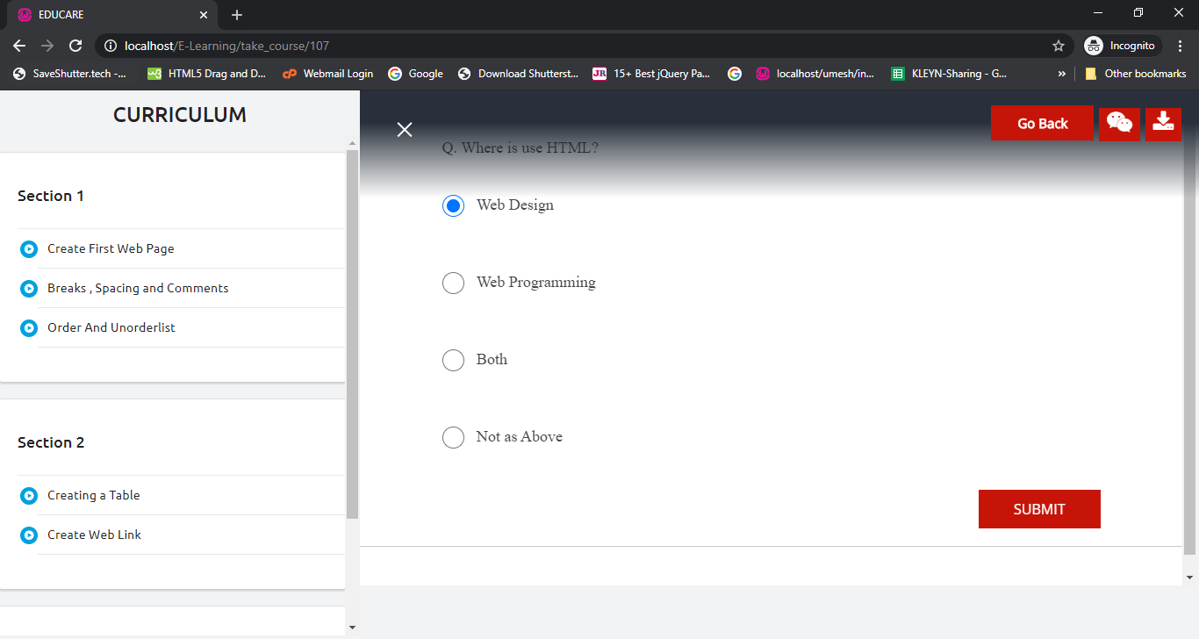

**After Give Exam User Can See Result**

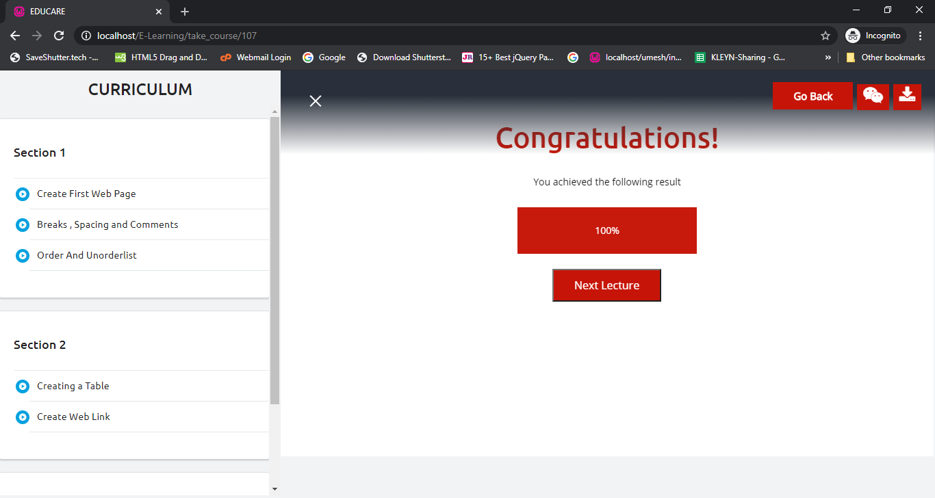

**User Can Download Material Related the Course**

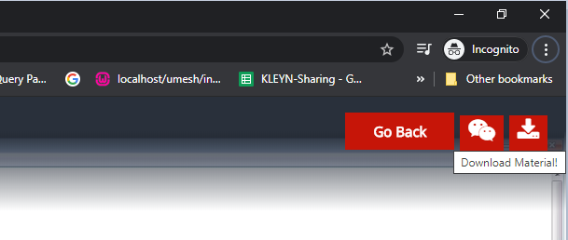

**User can Download and Read Material Related to Course**

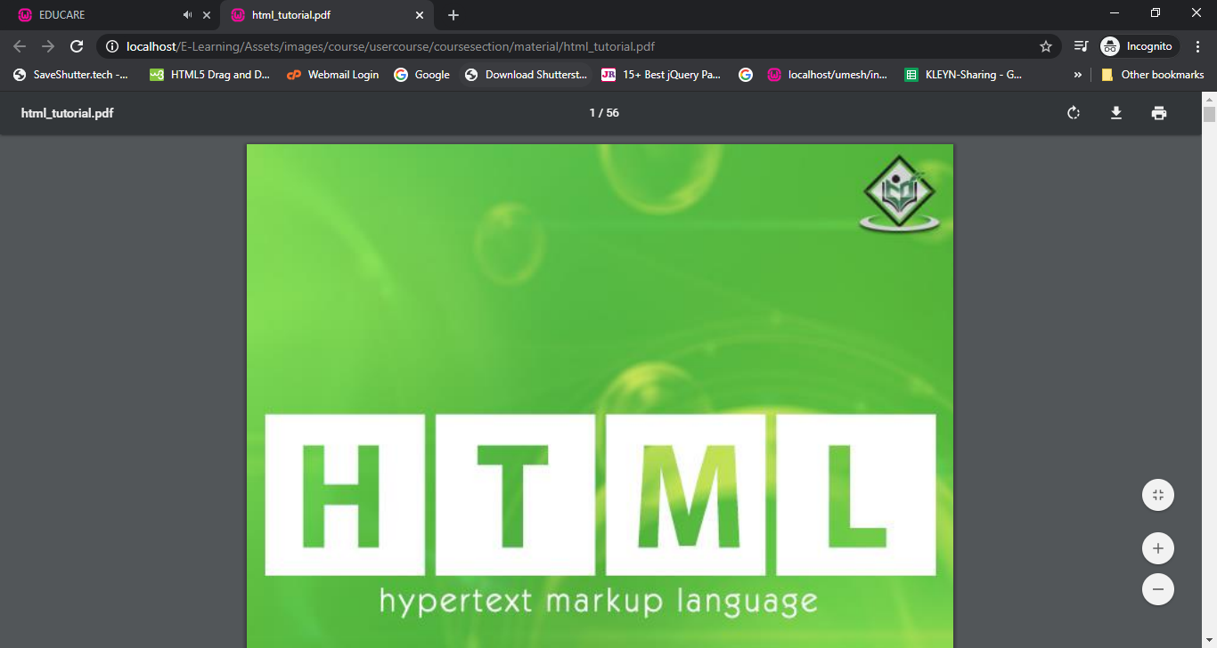

**Admin Dashboard**  
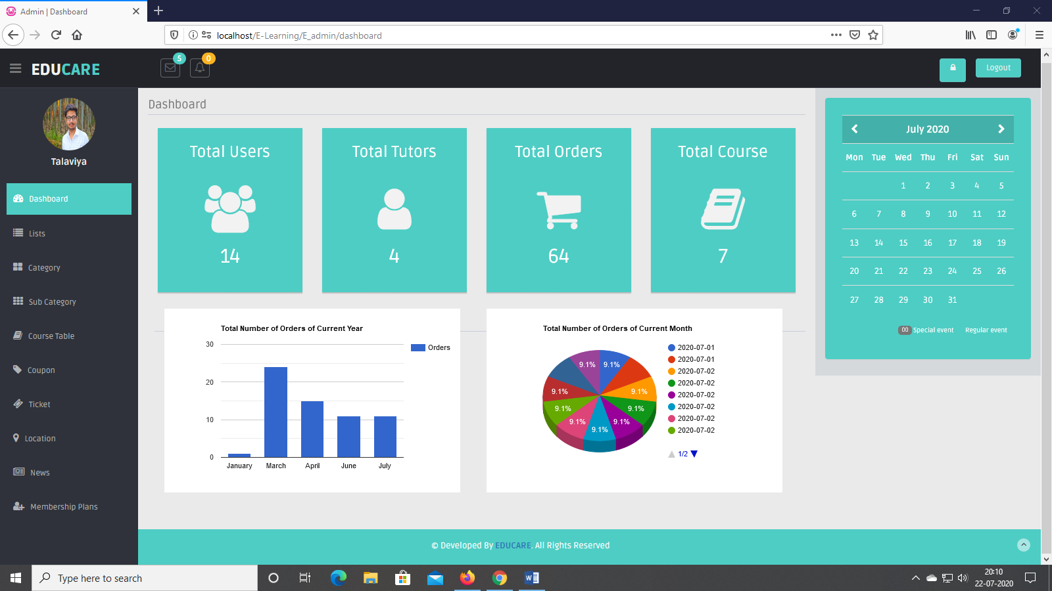

**Admin Profile**

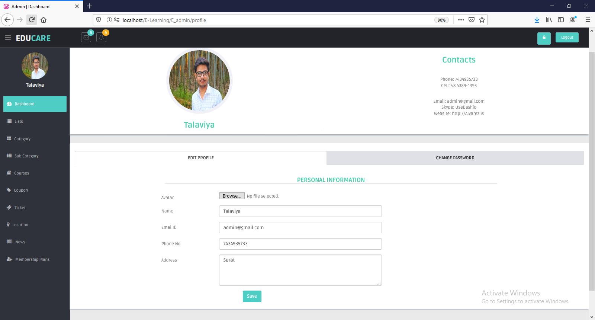

**Admin Change Password**

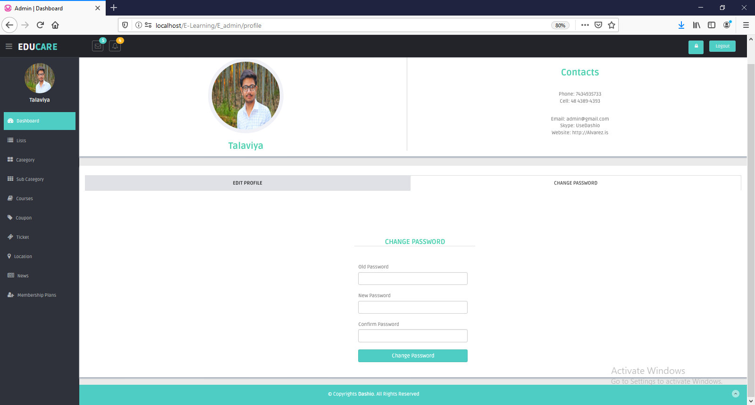

**Admin Side Add New Category**

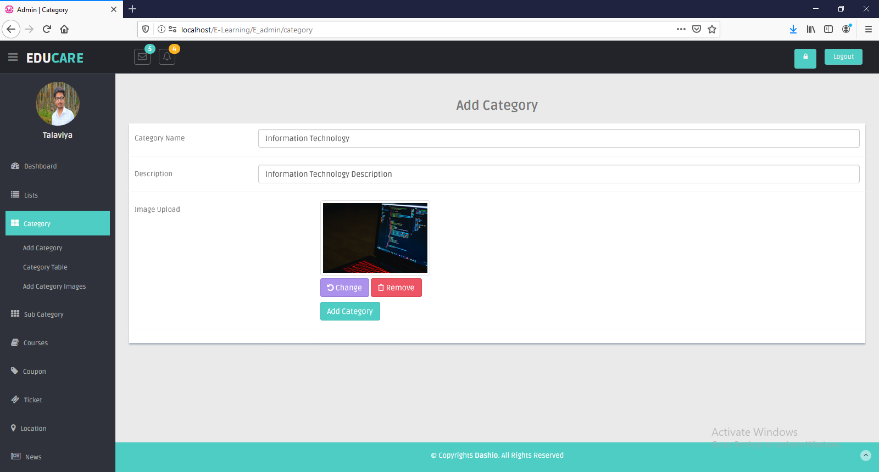

**Admin Side Add New Subcategory**

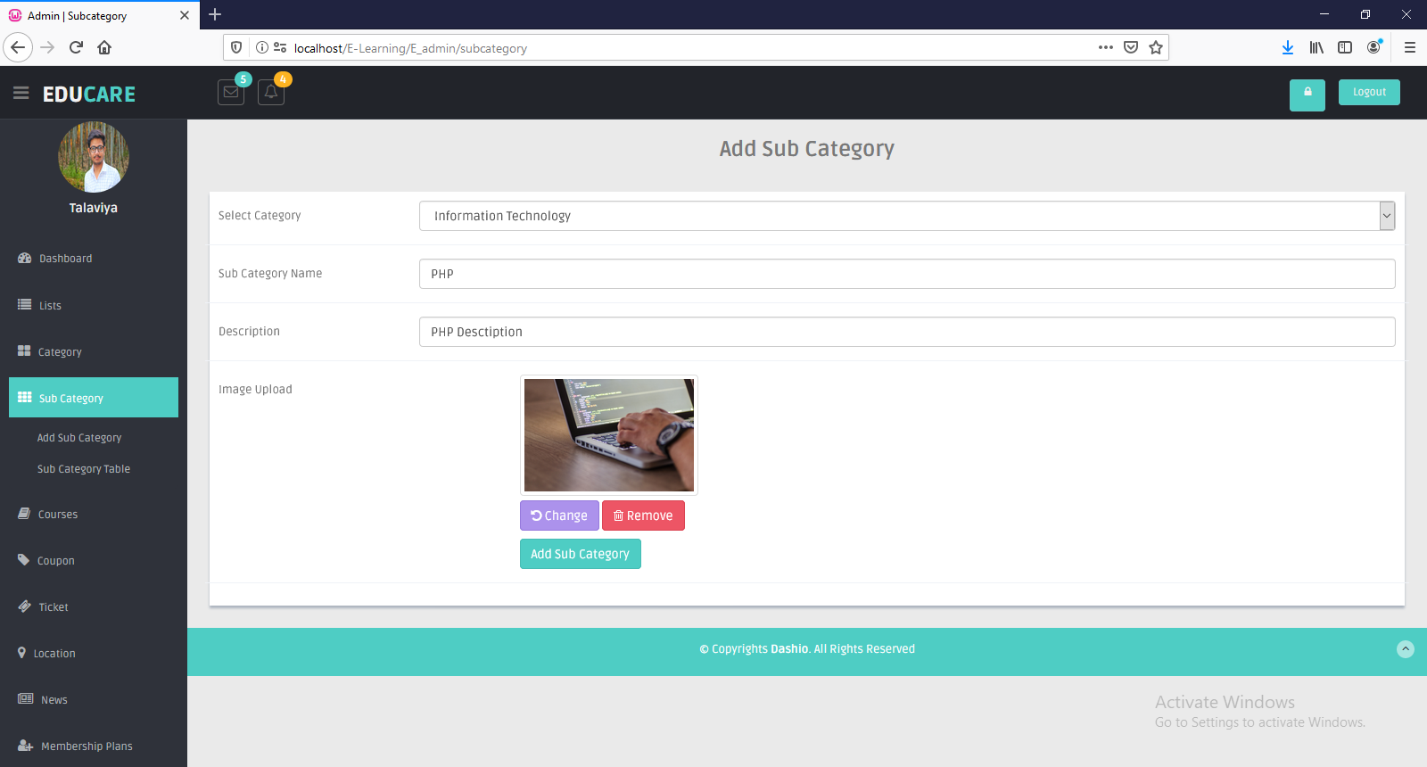

**Admin Side Add Multiple Images of Category**

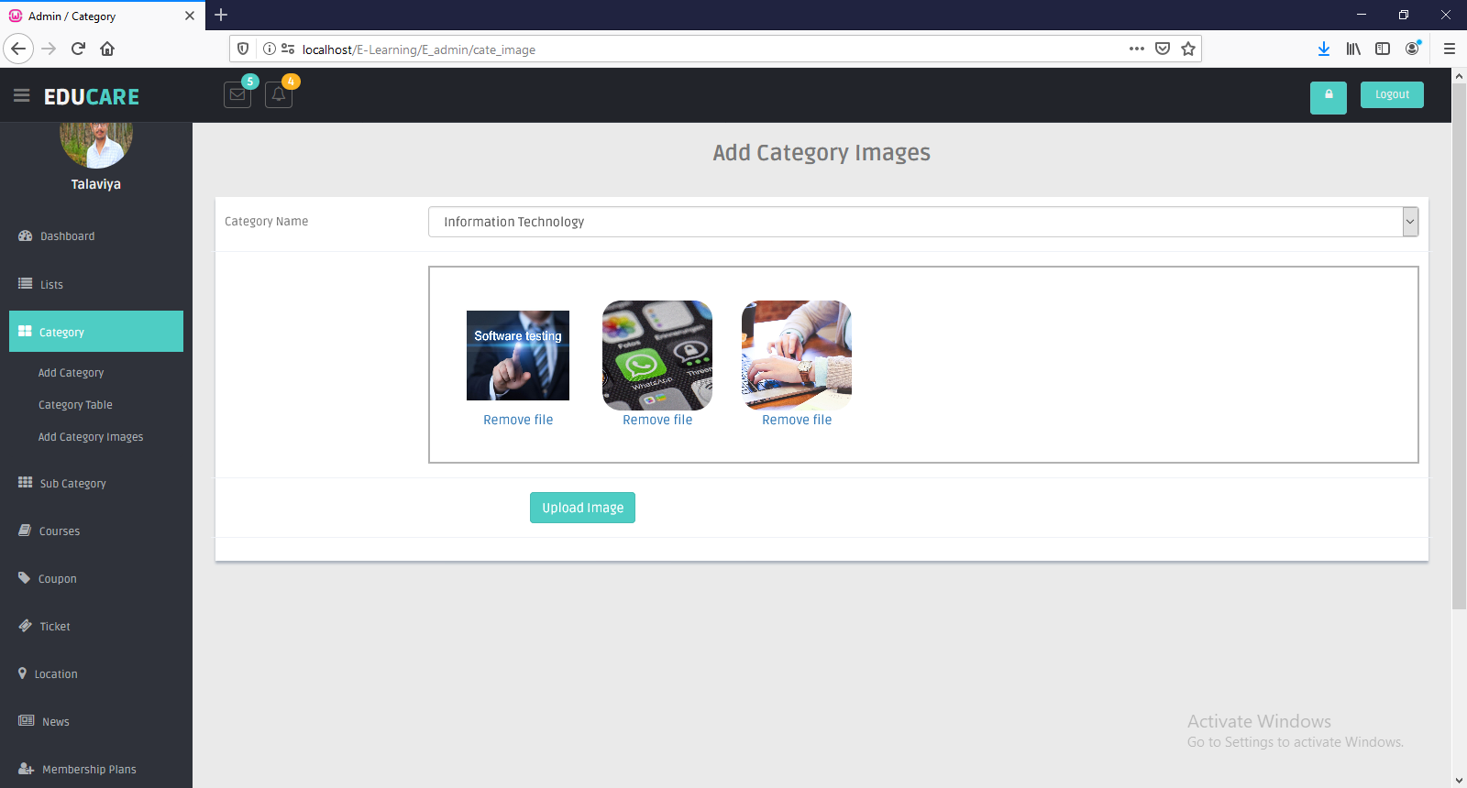

**Admin Can Add Coupon**

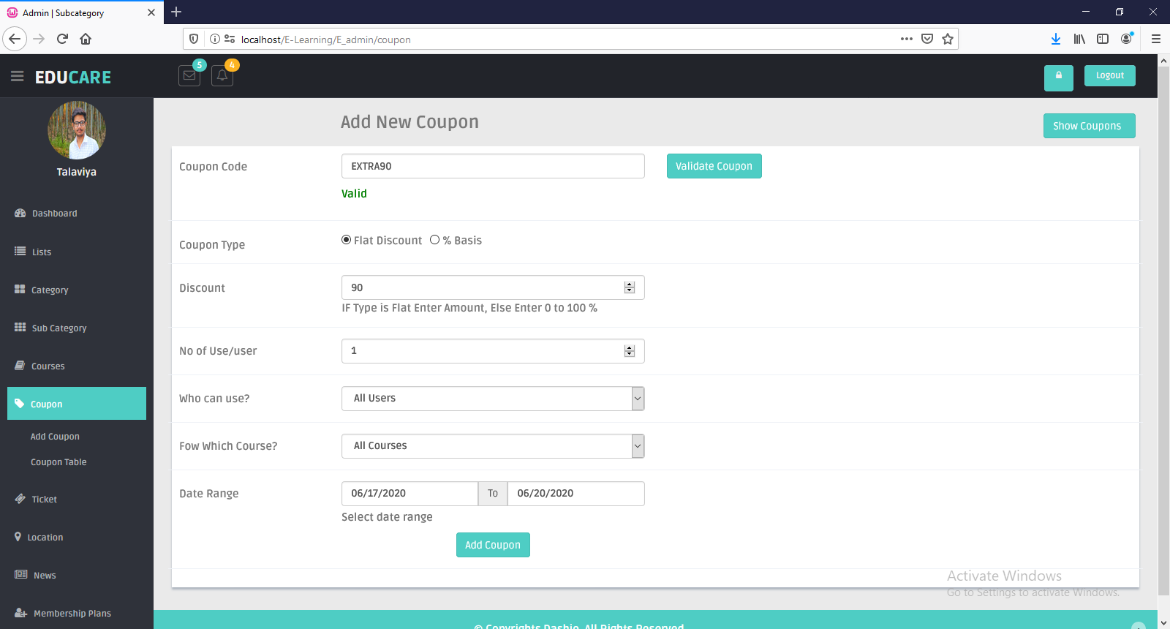

**Admin Can Add Location**

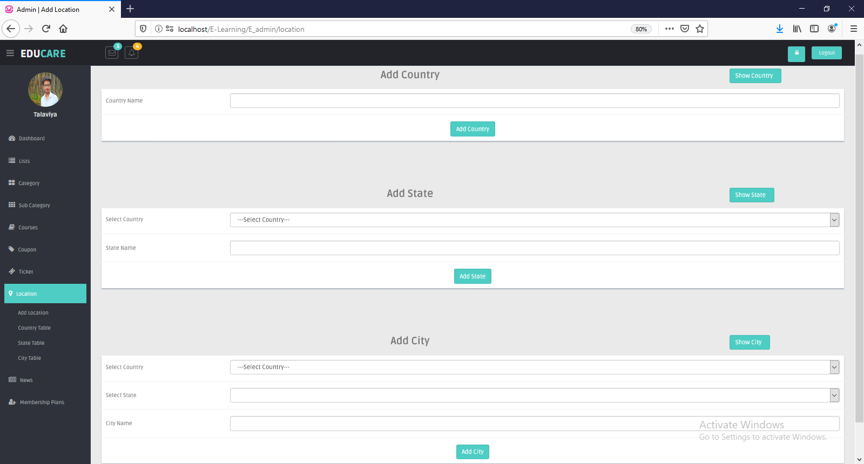

**Admin Can Add Membership**

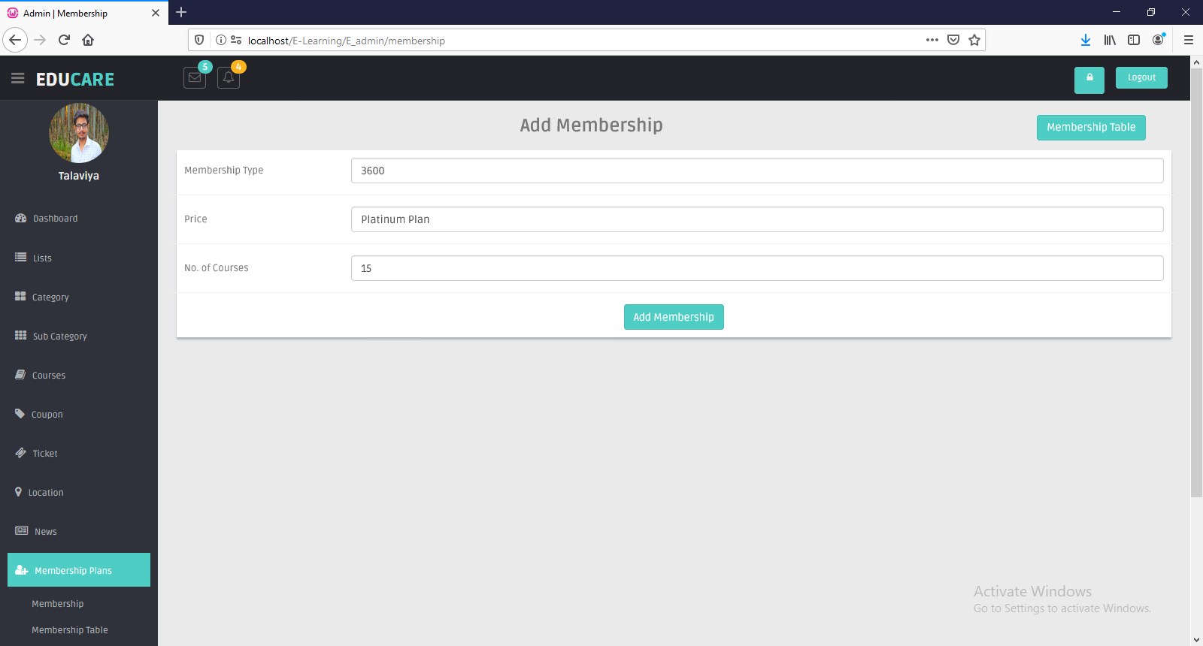

# Testing

## Software Testing

* **Software testing**
* Software testing is the process of evaluation a software item to detect differences between given input and expected output. Also, to assess the feature of a software item. Testing assesses the quality of the product.
* Software testing is a process that should be done during the development process. In other words, software testing is a verification and validation process.
* **Verification**
* Verification is the process to make sure the product satisfies the conditions imposed at the start of the development phase. In other words, to make sure the product behaves the way we want it to.
* **Validation**
* Validation is the process to make sure the product satisfies the specified requirements at the end of the development phase. In other words, to make sure the product is built as per customer requirements.

## Unit Testing

* **Unit testing**
* Unit testing focuses verification effort on the smallest unit of software design - the software component or module. Using the component-level design description as a guide, important control paths are tested to uncover errors within the boundary of the module. The unit test focuses on the internal processing logic and data structures within the boundaries of a component. This type of testing can be conducted in parallel for multiple components.
* Unit testing is a level of software testing where individual units/components of software are tested. The purpose is to validate that each unit of the software performs as designed. A unit is the smallest testable part of any software. It usually has one or a few inputs and usually a single output.
* Unit testing is a [software](https://searchmicroservices.techtarget.com/definition/software) development process in which the smallest testable parts of an [application](https://searchsoftwarequality.techtarget.com/definition/application), called units, are individually and independently scrutinized for proper operation. Unit testing can be done manually but is often [automated](https://searchitoperations.techtarget.com/definition/agile-test-automation-pyramid).
* Unit testing is a component of [test-driven development (TDD)](https://searchsoftwarequality.techtarget.com/definition/test-driven-development), a pragmatic methodology that takes a meticulous approach to building a product by means of continual testing and revision. Test-driven development requires that developers first write failing unit tests. Then they write code and refactor the application until the test passes. TDD typically results in an explicit and predictable code base.
* Unit testing involves only those characteristics that are vital to the performance of the unit under test. This encourages developers to modify the [source code](https://searchmicroservices.techtarget.com/definition/source-code) without immediate concerns about how such changes might affect the functioning of other units or the program as a whole. Once all of the units in a program have been found to be working in the most efficient and error-free manner possible, larger components of the program can be evaluated by means of [integration testing](https://searchsoftwarequality.techtarget.com/definition/integration-testing).

## System Testing

* **System testing**
* In this testing we take the requirements document as a reference to see whether the software meets all its requirements, goal or not.
* The objective of the system testing is to promote software functionality, reliability and maintainability.
* We used some testing in our system such as:

1. Recovery testing:
   * + In this testing we verify that if any failure occurred in our system then its recover proper or not.
2. Security testing

* In this testing, we attempt to verify that protection mechanism of our system. In our system we check the security such as login and password security. If any user wants to access our deep information and want to use our services then he/she must have to be login and other user cannot access or see the information of another us.

**Test cases-Registration Module:**

|  |  |  |  |  |  |  |
| --- | --- | --- | --- | --- | --- | --- |
| No | Field Name | Input | Valid/  Invalid | Expected  Output | Actual  Output | Result |
| 1 | Name | Null | Invalid | Your name is required | Your name is required | Pass |
|  |  | Jil123 | Invalid | Numeric Value Not Allowed | Numeric  Value Not Allowed | Pass |
|  |  | Jil | Valid | - | - | Pass |
| 2 | Email id | Null | Invalid | Your Email is required | Your Email is required | Pass |
|  |  | jil4.com | Invalid | Enter Valid  Email id | Enter Valid  Email id | Pass |
|  |  | jil4@gmail.com | Valid | - | - | Pass |
| 3 | Password | Null | Invalid | Your password is required | Your password is required | Pass |
|  |  | Less than 7 character | Invalid | Password  Must be 7 character | Password  Must be 7 character | Pass |
|  |  | jil123 | Valid | - | - | Pass |
| 4 | Phone no | Null | Invalid | Your password is required | Your password is required | Pass |
|  |  | Greater than 10 number | Invalid | Your contact field is not in the correct format | Your contact field is not in the correct format | Pass |
|  |  | 8849352556 | Valid | - | - | Pass |
| 5 | Date of Birth | Null | Invalid | Date of birth is required | Date of birth is required | Pass |

**Test cases-Login Module:**

|  |  |  |  |  |  |  |
| --- | --- | --- | --- | --- | --- | --- |
| No | Field Name | Input | Valid/  Invalid | Expected  Output | Actual  Output | Result |
| 1 | Email id | Null | Invalid | Your Email is required | Your Email is required | Pass |
|  |  | jil.com | Invalid | Enter Valid  Email id | Enter Valid  Email id | Pass |
|  |  | Jil4@gmail.com | Valid | - | - | Pass |
| 2 | Password | Null | Invalid | Your password is required | Your password is required | Pass |
|  |  | Less than 7 character | Invalid | Password  Must be 7 character | Password  Must be 7 character | Pass |
|  |  | Jil10179 | Valid | Login | Login | Pass |

**Test cases-Change Password Module:**

|  |  |  |  |  |  |  |
| --- | --- | --- | --- | --- | --- | --- |
| No | Field Name | Input | Valid/Invalid | Expected  output | Actual  Output | Result |
| 1 | Old Password | Null | Invalid | Your Old Password field is required. | Your Old Password field is required. | Pass |
|  |  | Jil10179 | Valid | - | - | Pass |
| 2 | New password | Null | Invalid | Your New Password field is required. | Your New Password field is required. | Pass |
|  |  | Jil1255 | Valid | - | - | Pass |
| 3 | Re-enter password | Null | Invalid | Your New Password field is required | Your New Password field is required | Pass |
|  |  | Jil10179 | Invalid | New Password and Confirm Password are not same | New Password and Confirm Password are not same | Pass |
|  |  | Jil1255 | Valid | - | - | Pass |

**Test cases business login:**

|  |  |  |  |  |  |  |
| --- | --- | --- | --- | --- | --- | --- |
| No | Field Name | Input | Valid/  Invalid | Expected  Output | Actual  Output | Result |
| 1 | Name | Null | Invalid | Your name is required | Your name is required | Pass |
|  |  | Dhara123 | Invalid | Numeric Value Not Allowed | Numeric  Value Not Allowed | Pass |
|  |  | Dhara | Valid | - | - | Pass |
| 2 | City | Null | Invalid | City is required | City is required | pass |
|  |  | Surat | Valid | - | - | Pass |
| 3 | Pin code | Null | Invalid | Pin code is required | Pin code is required | pass |
|  |  | 395006 | Valid | - | - | Pass |
| 4 | Email id | Null | Invalid | Your Email is required | Your Email is required | Pass |
|  |  | dhara4.com | Invalid | Enter Valid  Email id | Enter Valid  Email id | Pass |
|  |  | dhara4@gmail.com | Valid | - | - | Pass |
| 5 | Phone no | Null | Invalid | Your password is required | Your password is required | Pass |
|  |  | Greater than 10 number | Invalid | Your contact field is not in the correct format | Your contact field is not in the correct format | Pass |
|  |  | 9979922102 | Valid | - | - | Pass |
| 6 | image | Null | Invalid | Please select image | Please select image | Pass |
|  |  | image | Valid | - | - | Pass |

**Test cases Add Event**

|  |  |  |  |  |  |  |
| --- | --- | --- | --- | --- | --- | --- |
| No | Field Name | Input | Valid/  Invalid | Expected  Output | Actual  Output | Result |
| 1 | Event Name | Null | Invalid | Event name is required | Event name is required | Pass |
|  |  | Marriage | Valid | - | - | Pass |
| 2 | Description | Null | Invalid | Description is required | Description is required | pass |
|  |  | About event | Valid | - | - | Pass |
| 3 | Image | Null | Invalid | Please select image | Please select image | Pass |
|  |  | Image | Valid | - | - | Pass |

**Test cases Add Gallery**

|  |  |  |  |  |  |  |
| --- | --- | --- | --- | --- | --- | --- |
| No | Field Name | Input | Valid/  Invalid | Expected  Output | Actual  Output | Result |
| 1 | Event Name | Null | Invalid | Event name is required | Event name is required | Pass |
|  |  | Marriage | Valid | - | - | Pass |
| 2 | Image | Null | Invalid | Please select image | Please select image | Pass |
|  |  | Image | Valid | - | - | Pass |

**Future Enhancement**

* + - After the positive response of the student, we will try to do that, what the student really wants from us.
    - We will add some general knowledge concept which is totally free, it will help students who want to give competitive exam.
    - We will try to give live video classes to all enrolled students.
    - We will be trying to give 24*7 hours feedback to students.
    - We will provide payment to faculty for courses.
    - Just a single project, it doesn’t mean that all things are covered, we’ll try for newness.

**Conclusion**

* Online Education has brought a positive impact in the lives of students and working professionals. It has given an opportunity to take up additional courses along with their studies or job as per their convenience.
* Online education has also helped the faculty in the institutions to ask students to study some part of syllabus online which do not require much of classroom instructions. So, the online study helps the faculty to save time in which they can interact with the students more.
* The quality of education has improved by online courses and even it has become easy for students to refer the content as per their leisure. In the era of digitalization, the scope of online education increases even more and will be beneficial for students, professionals and also institutions

# Reference

* **Book reference**
* PHP Bible 2nd edition
  + Author: Tim Converse, Joyce Park
  + Publisher: John Wiley and Sons
* Php Professional CodeIgniter 1st edition
  + Author: Thomas Myer
  + Publisher: Wrox
* E-learning in 21st Century 2nd edition
  + Author: D.Randy Garrison
  + Publisher: Taylor & Francis Group
* E-learning Tools and Technology 1st edition
  + Author: William Horton, Katherine Horton.
  + Publisher: Wiley Publishing Inc.
* **Web reference**
* <https://www.w3schools.com>/php/
* <https://www.udemy.com/>
* <https://unacademy.com/>
* <https://www.hostinger.in/tutorials/codeigniter-tutorial>/
* <https://codeigniter.com/>
* <https://www.khanacademy.org/>
* <https://www.coursera.org/>